

**Format No. QSP/7.1/01.F01 (B) Issue No.05 Rev. No 5 Dated: Jan 1, 2017**

**_____________________________________________________________**

**UNIVERSITY OF PETROLEUM & ENERGY STUDIES**

**College of Engineering Studies**

**Dehradun**

**LAB FILE**

Programme : B. Tech in Computer Science and Engineering with

Specialization in DevOps

Course : Build and Release Management Lab

No. of credits : 1

Semester : IV

Session : Jan-May 2020

Batch : 2018-2022

Faculty : Dr. Hitesh Kumar Sharma

**Submitted By:**

**Roll No.: - R171218005**

**SAP ID: - 500067644**

**Name: - ABHISHEK SHARMA**

**Faculty Signature**

**_____________________________________**

|  |  |
| --- | --- |
| ***S.NO.*** | ***Experiment*** |
| ***1*** | ***Create a java project using Maven*** |
| ***2*** | ***Unit Testing using Junit tool*** |
| ***3*** | ***Maven Build and usage in another Java Project*** |
| ***4*** | ***Install and Manage Maven Plugin Install Site Plugin*** |
| ***5*** | ***Working with Maven Repository*** |
| ***6*** | ***Create a simple Maven Project using CLI*** |
| ***7*** | ***Selenium IDE. Perform Automation testing using Selenium IDE for testing a web page.*** |
| ***8*** | ***Selenium WebDriver Perform Automation testing using Selenium Web Driver for testing a web page*** |
| ***9*** | ***Build Profile using maven*** |
| ***10*** | ***Integration using GitHub Create a complete Maven project and push in GitHub repository for Continuous Integration.*** |

**EXPERIMENT-1**

**Aim:**

**1.Create a Java Project using Maven.**

**2.Run the following maven goals on this project**

**3.Clean**

**4.Compile**

**5.Test-Compile**

**6.Install**

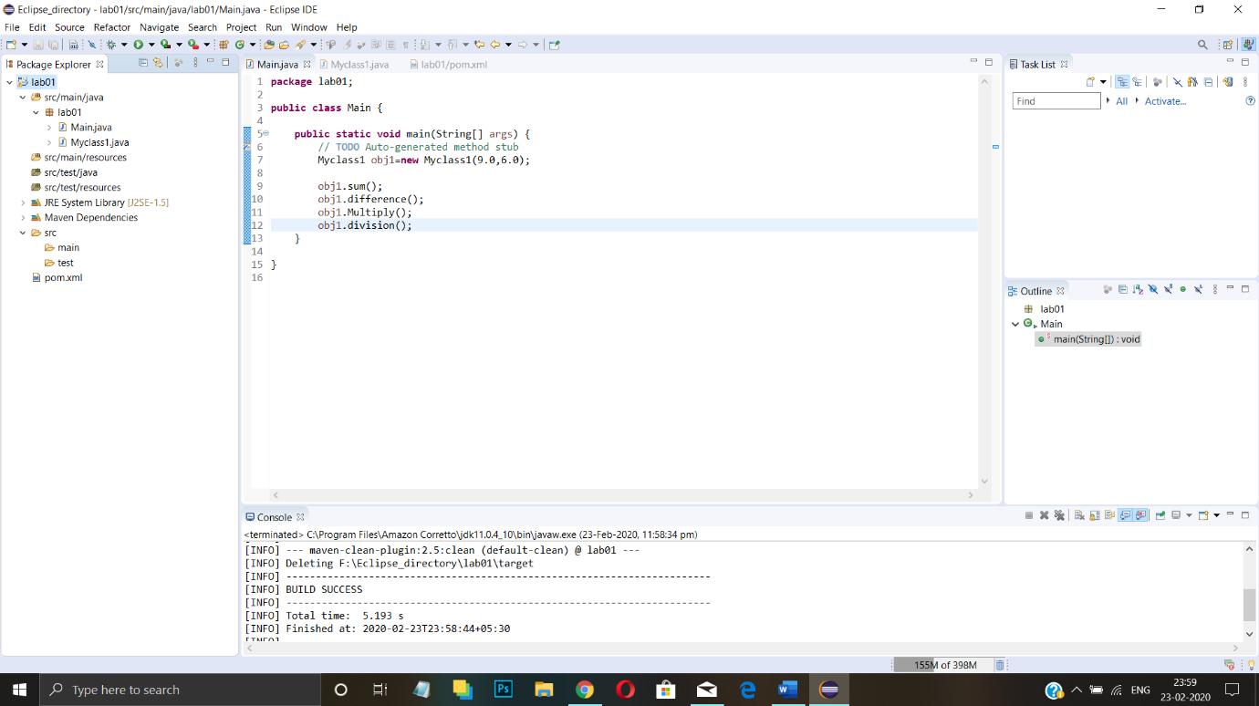

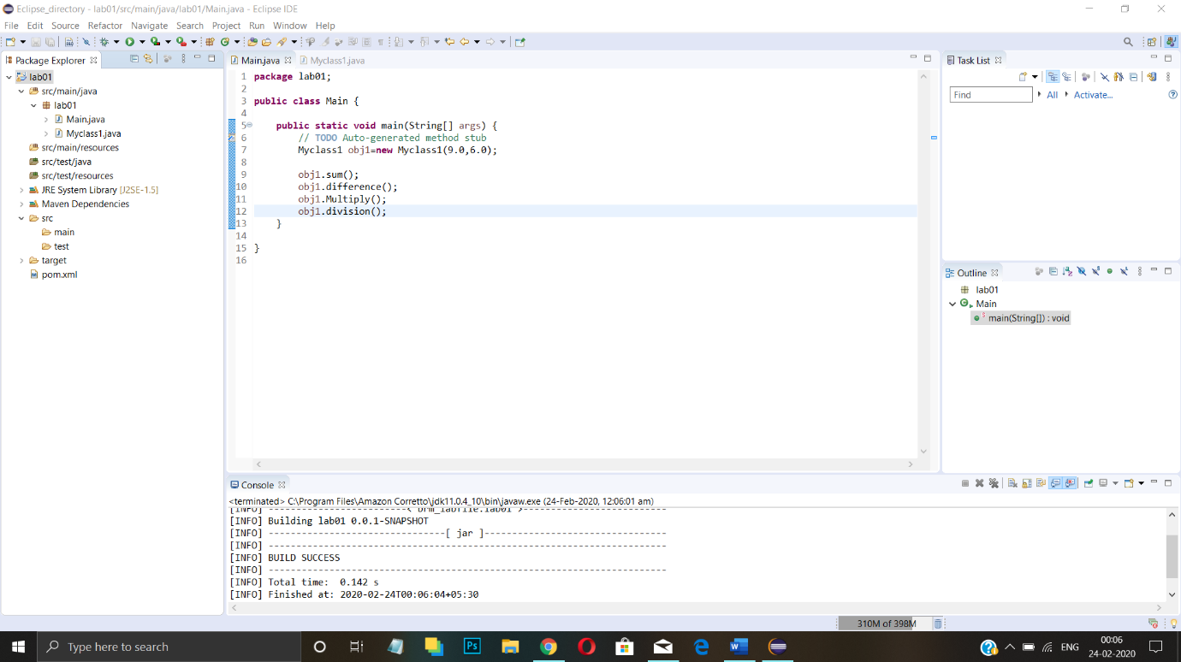

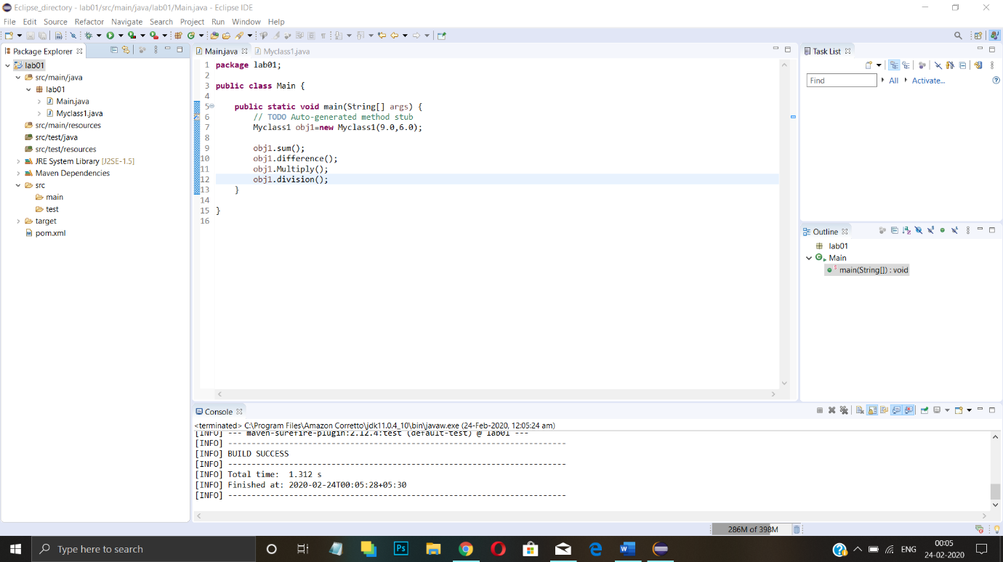

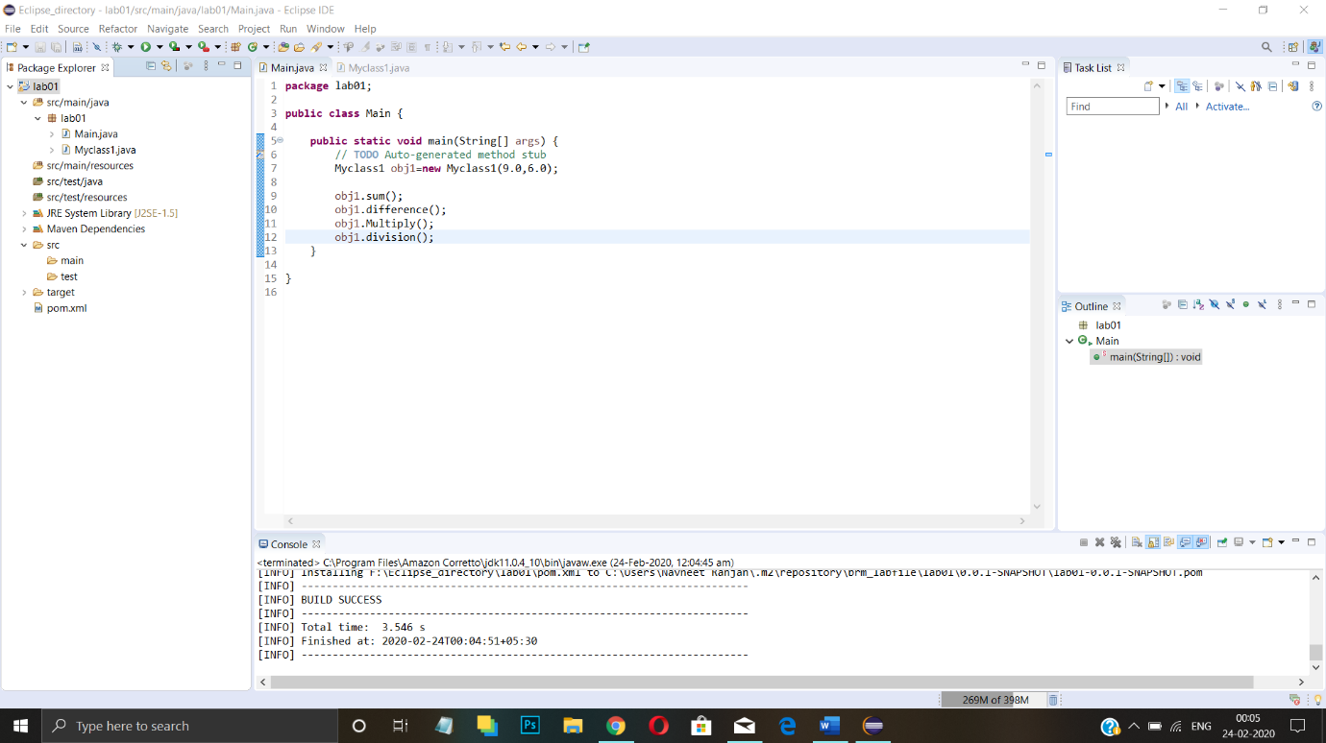

**EXPERIMENT-2**

**Aim: Unit Testing using Junit tool**

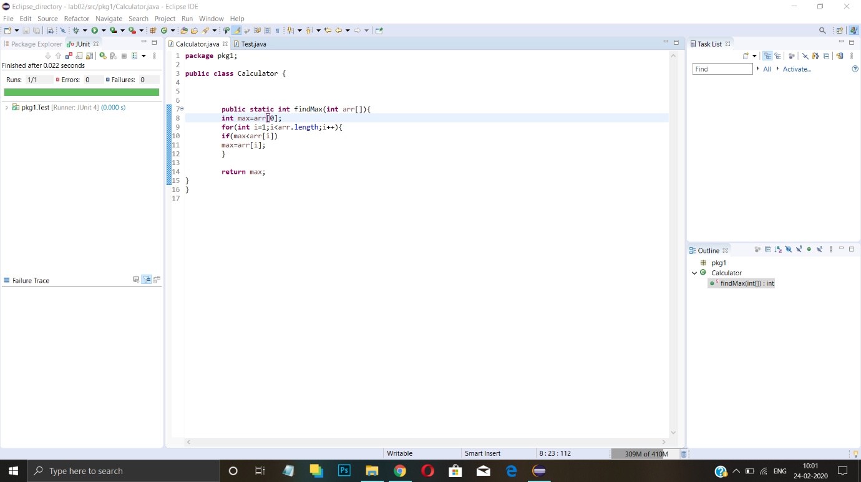

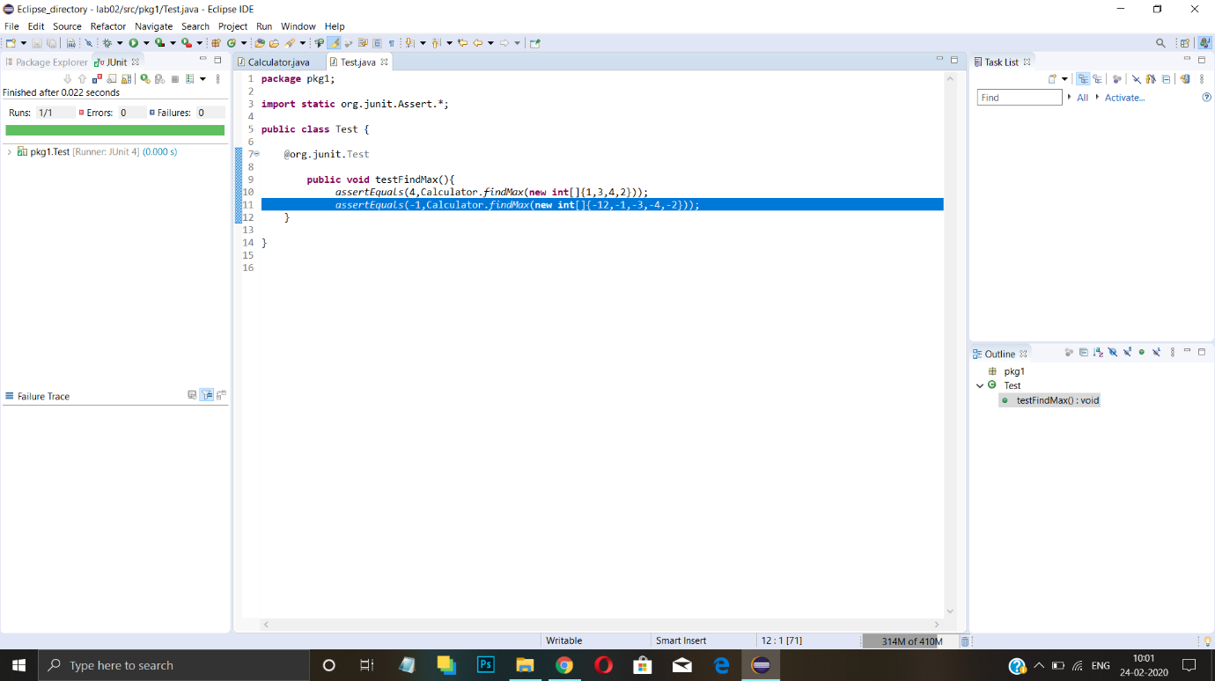

**EXPERIMENT-3**

**Aim: Maven Build and usage in another Java Project**

**1. Create a Build of java project using maven.**

**2. Use that build in some other Java Project.**

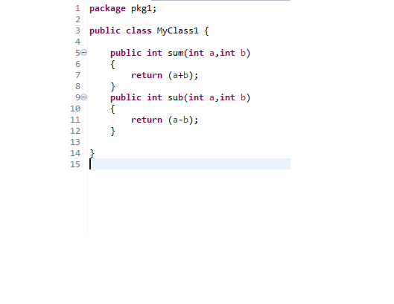

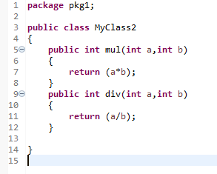

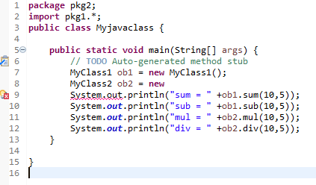

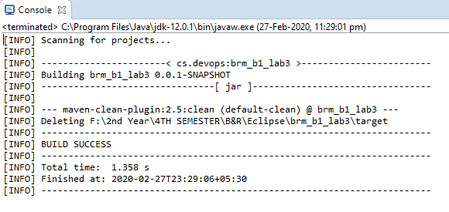

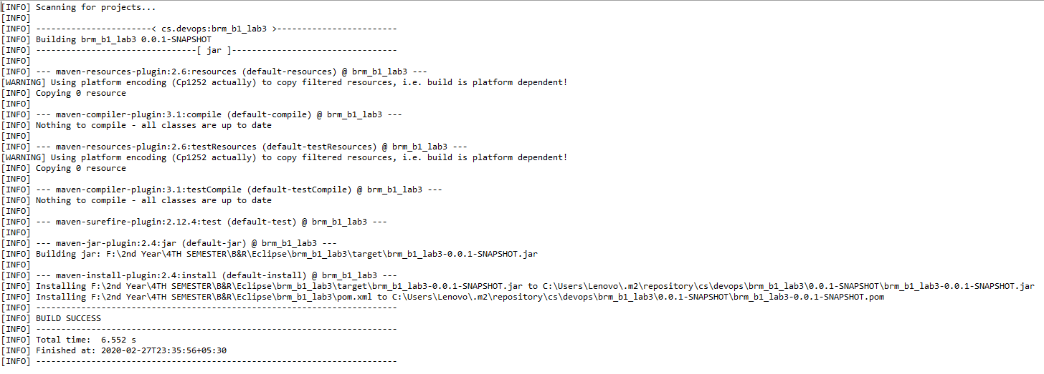

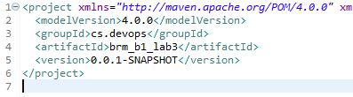

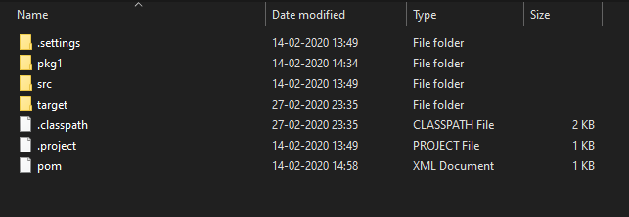

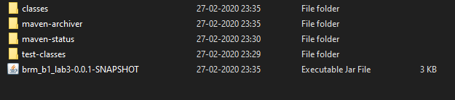

**EXPERIMENT-4**

**Aim: Install and Manage Maven Plugin Install Site Plugin and use “mvn site” command and goal for generating documents for Maven Project.**

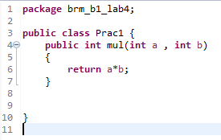

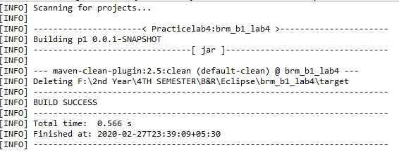

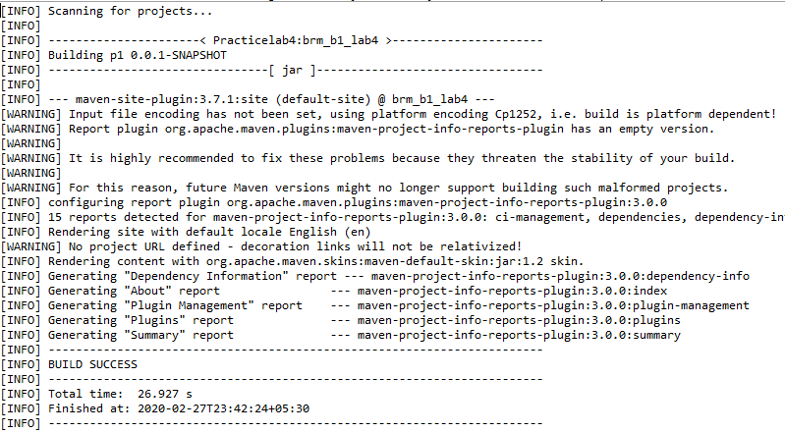

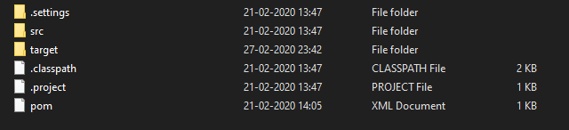

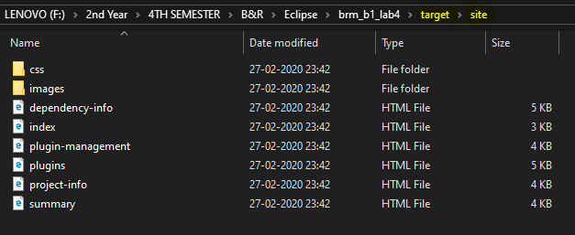

**EXPERIMENT-5**

**Aim: Working with Maven Repository**

1. **Add Central Repository (Hibernate)**

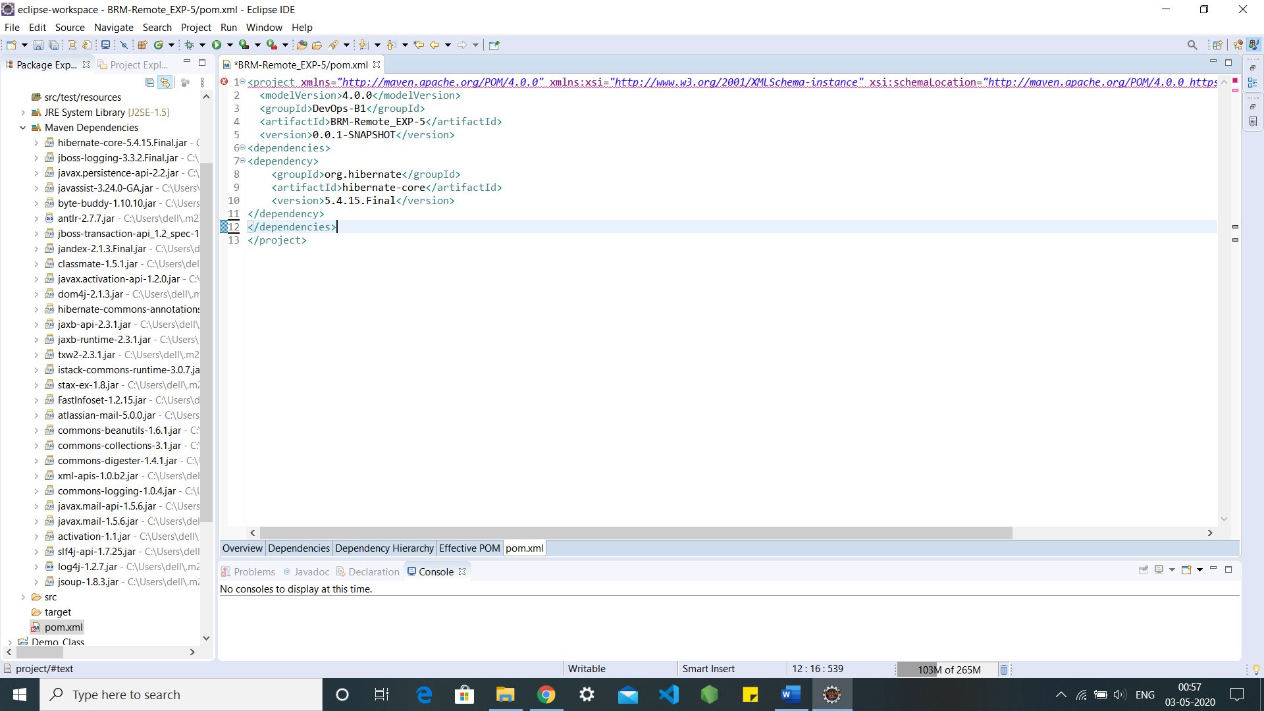

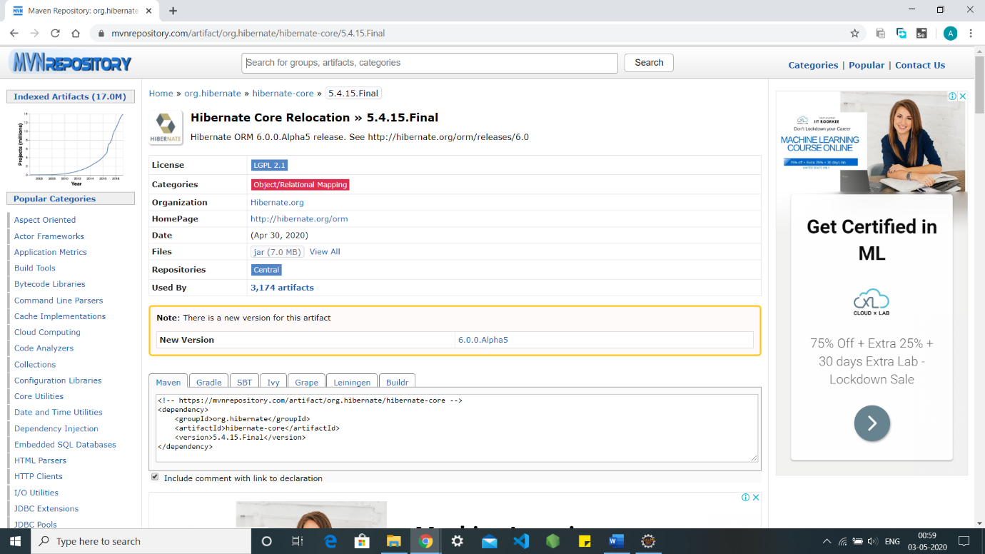

**2. Add Remote Repository (Atlassian Mail)**

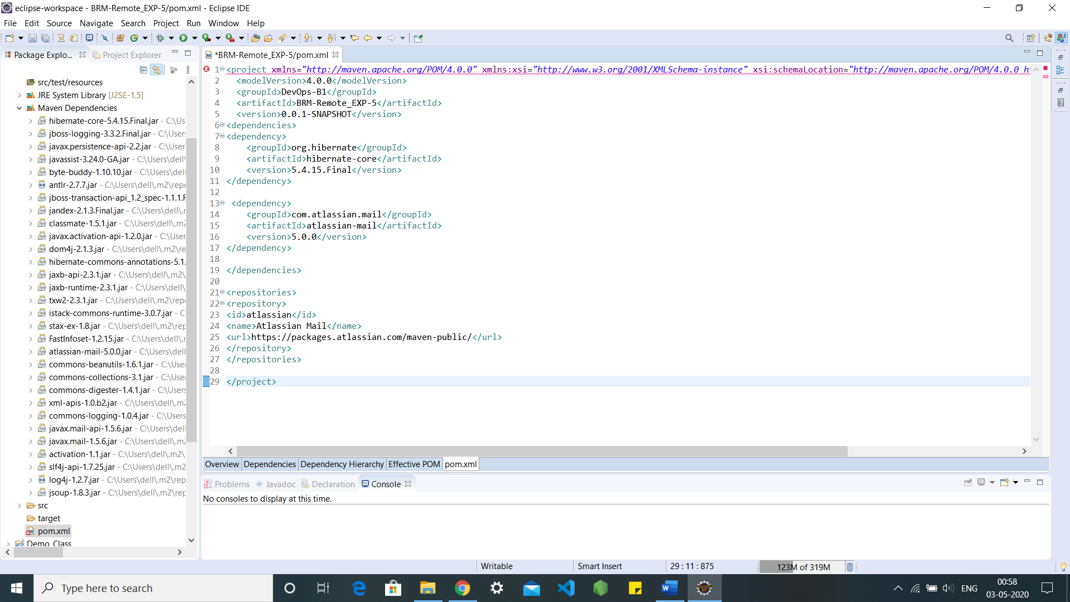

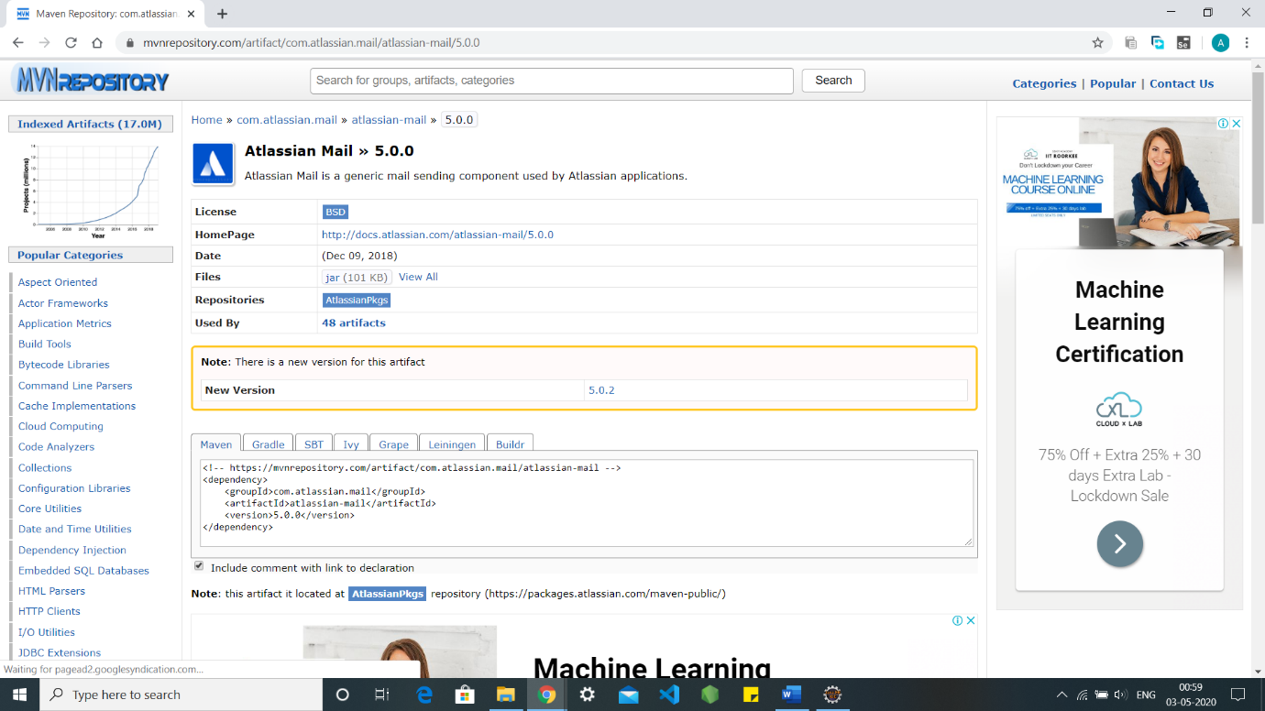

**EXPERIMENT-6**

**Aim: - Create a simple Maven Project using CLI.**

First, download Maven and follow the installation instructions. After that, type the following in a terminal or in a command prompt:

**1. mvn --version**

It should print out your installed version of Maven: -

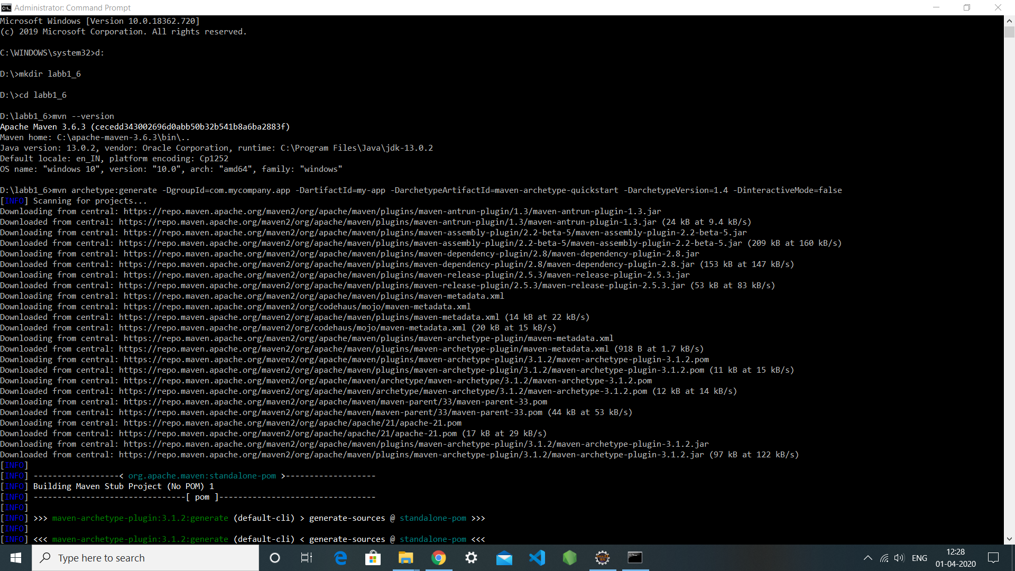

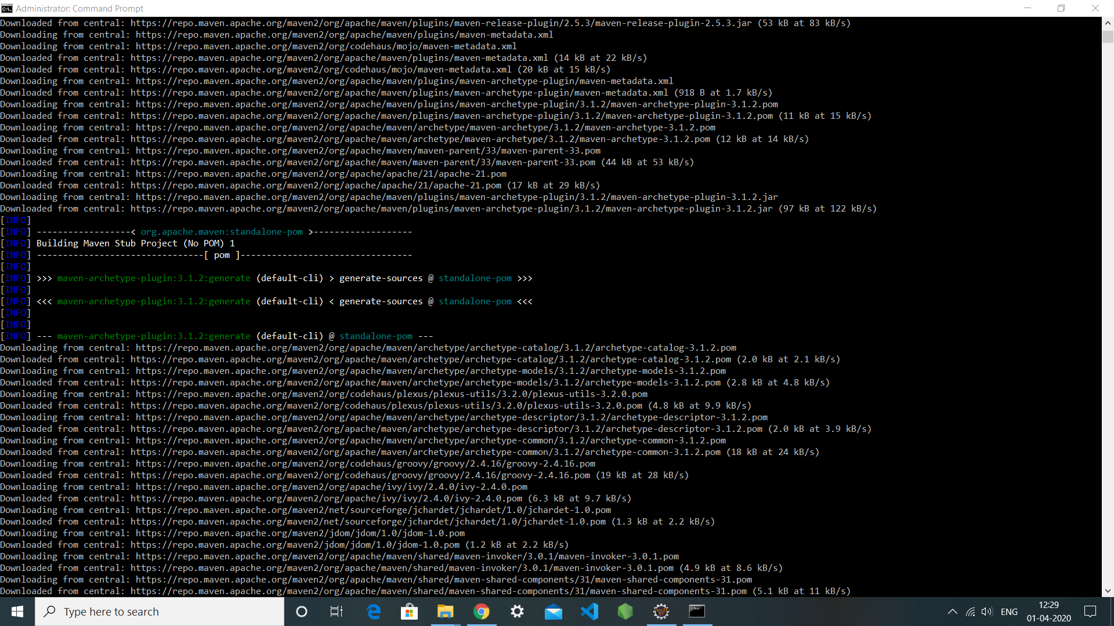

**Creating a Project**

**1. cd my-app**

Under this directory you will notice the following standard project structure.

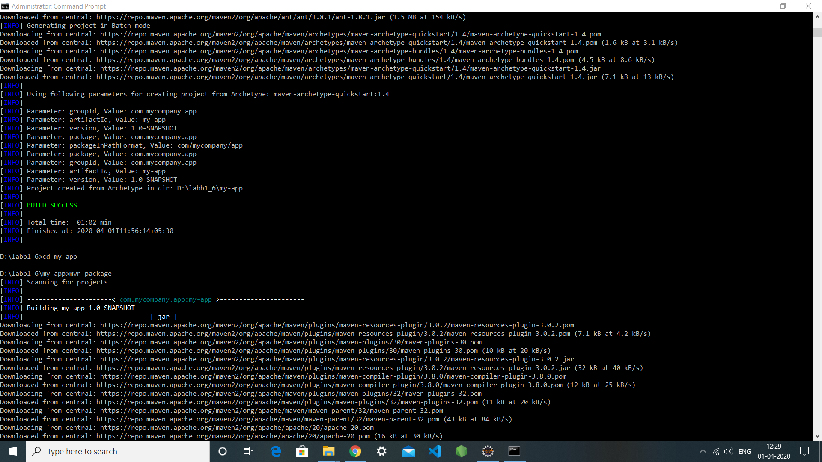

**The POM**

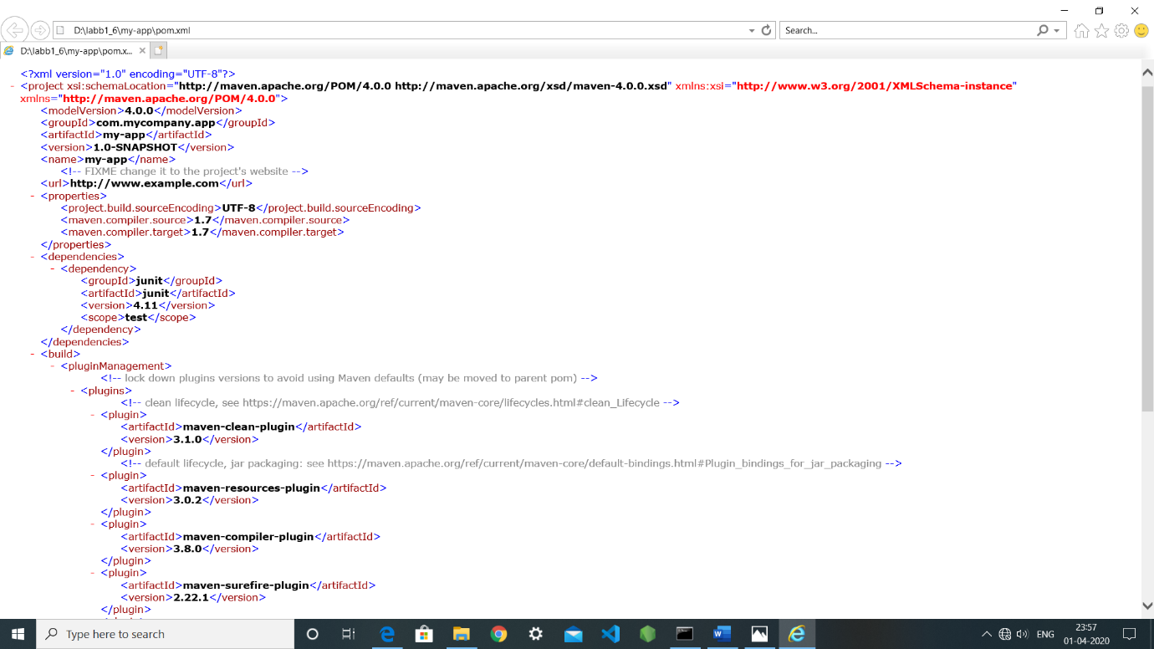

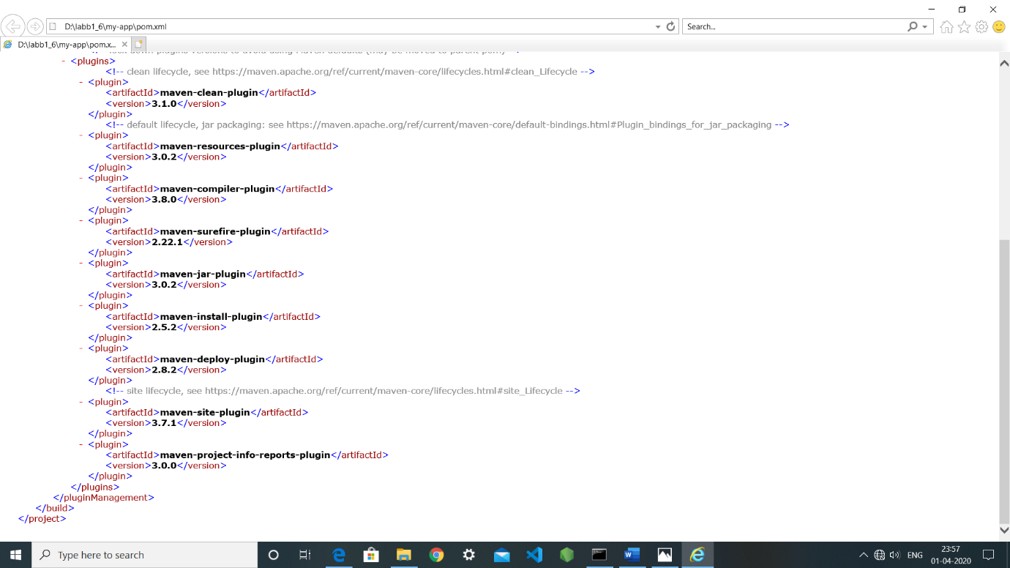

**Build the Project**

1. **mvn package**



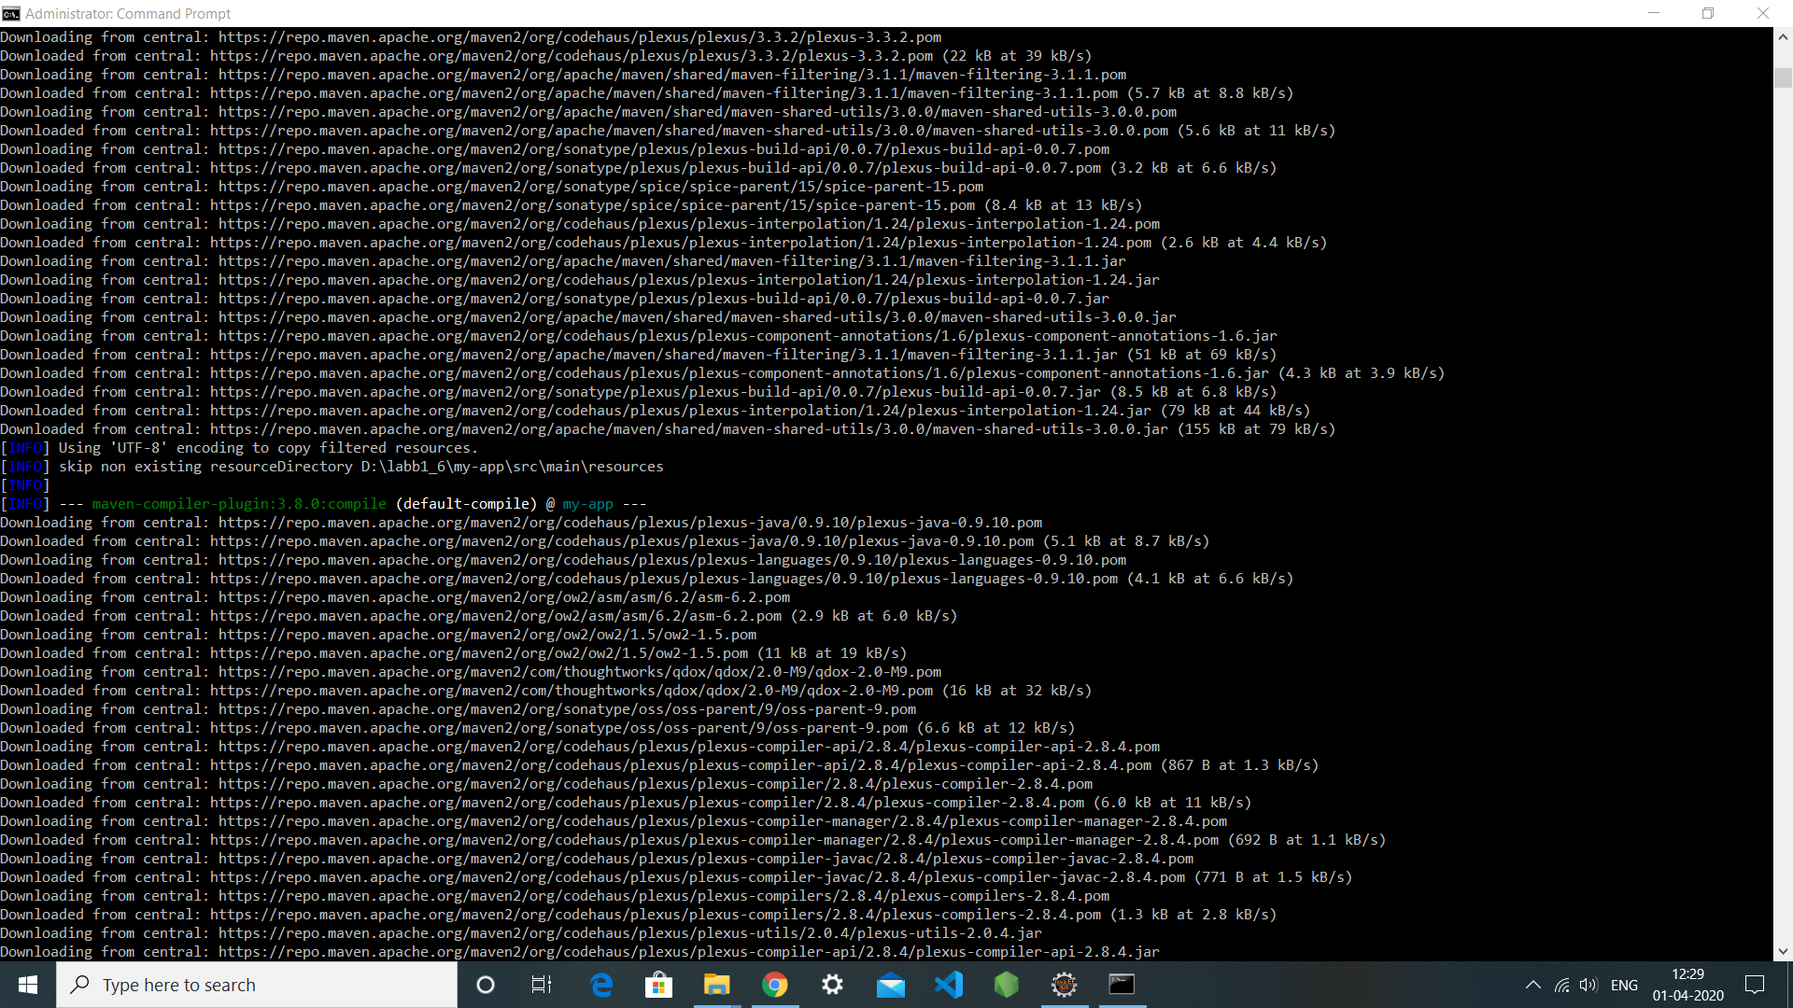

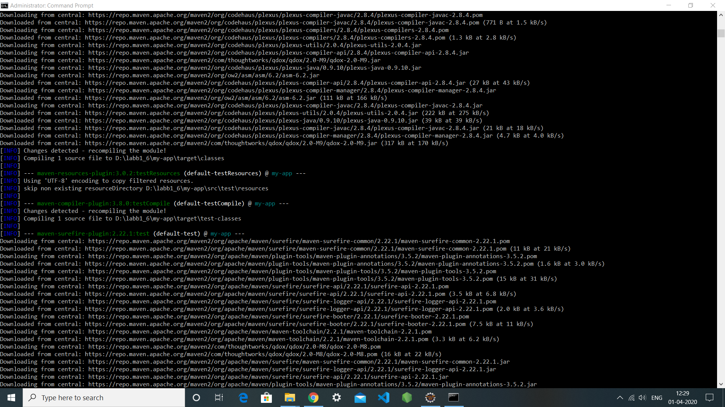

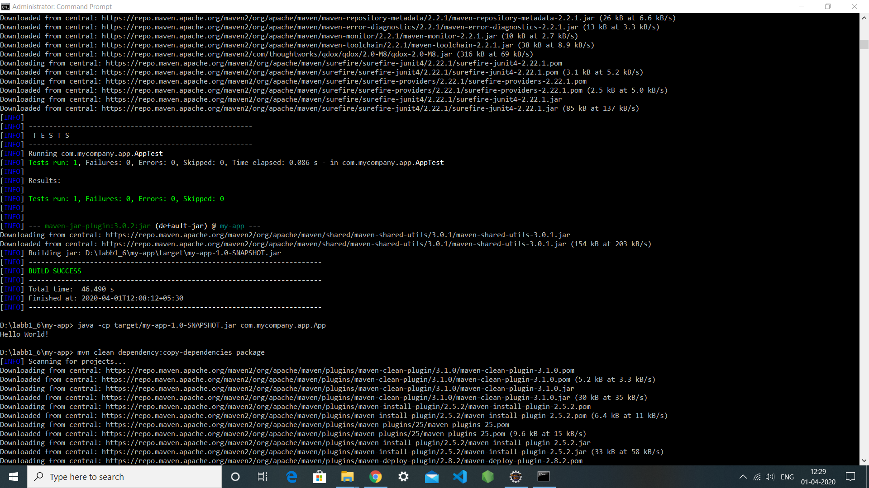

You may test the newly compiled and packaged JAR with the following command:

**1. java -cp target/my-app-1.0-SNAPSHOT.jar com.mycompany.app.App**

Which will print the quintessential:

1. **Hello World!**



1. **mvn clean dependency:copy-dependencies package**

This command will clean the project, copy dependencies, and package the project (executing all phases up to package, of course).



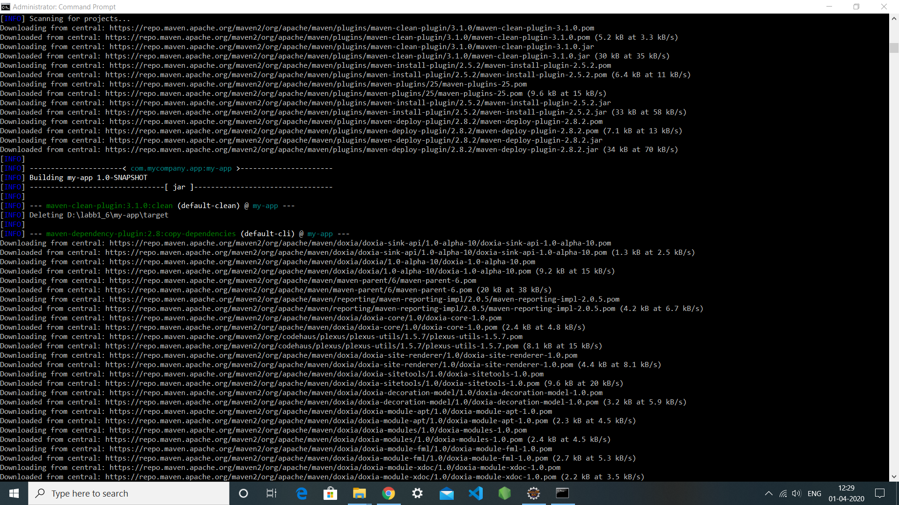

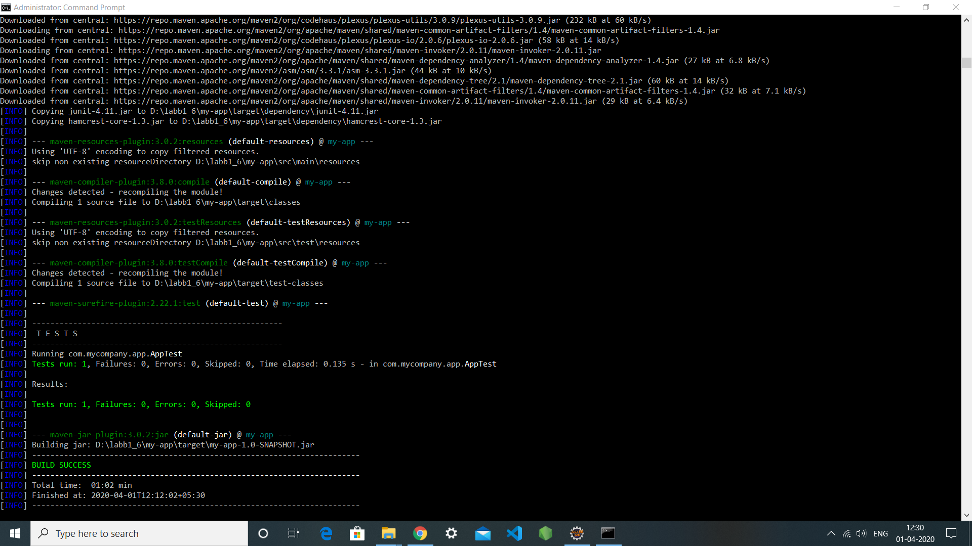

**Generating the Site**

**1. mvn site**

This phase generates a site based upon information on the project's pom. You can look at the documentation generated under target/site

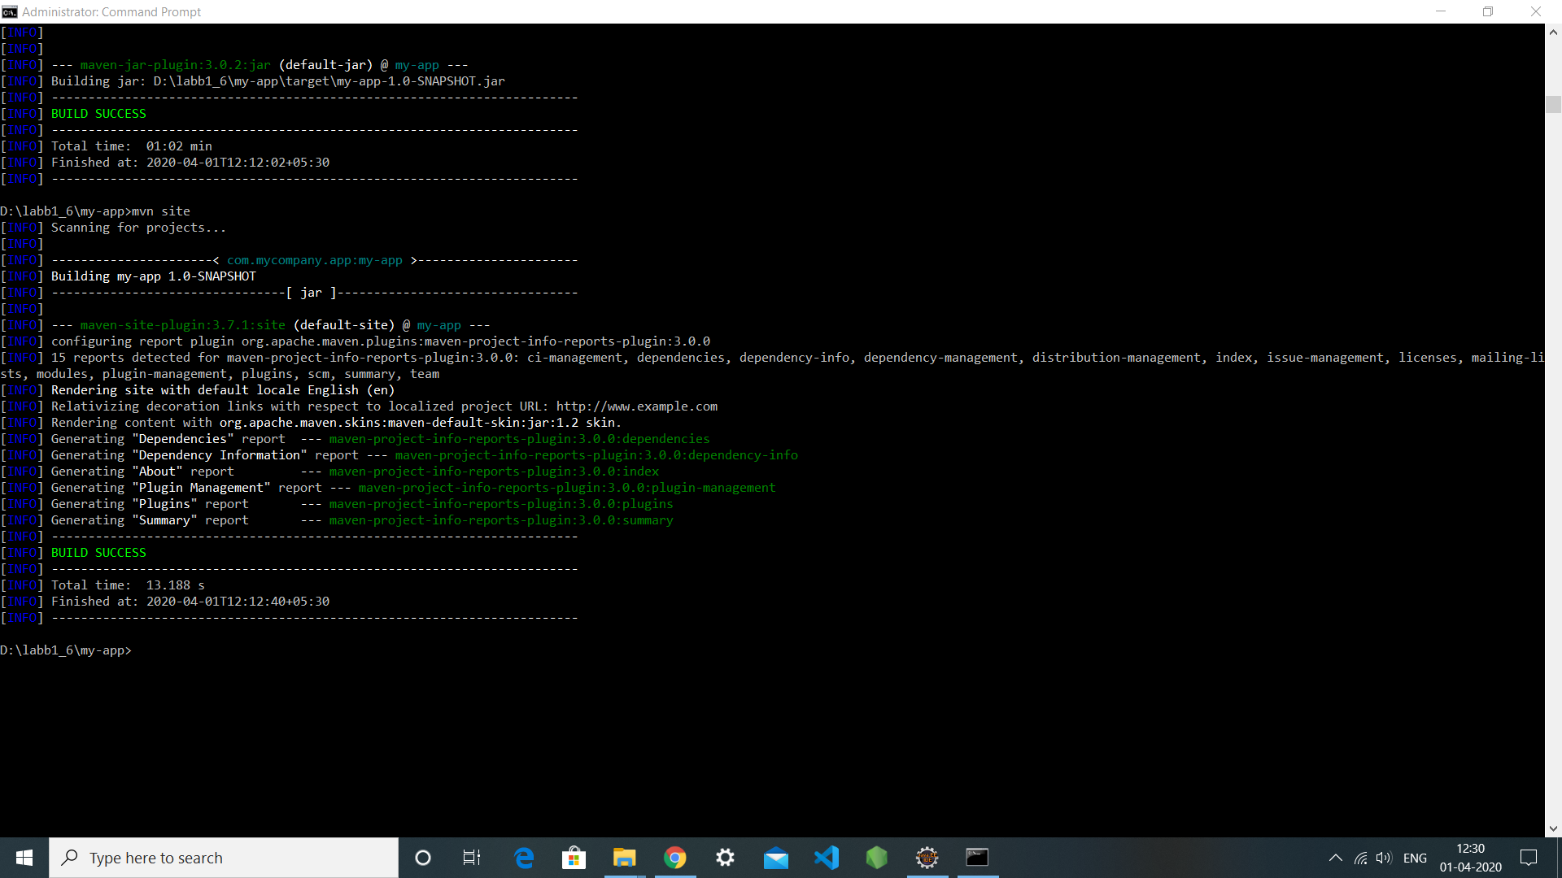

**EXPERIMENT-7**

**Aim: Selenium IDE. Perform Automation testing using Selenium IDE for testing a web page.**

By using selenium recording: -

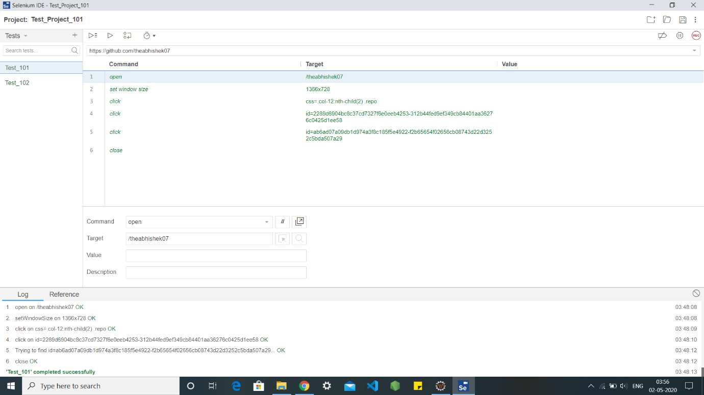

After removing “close” from the commands, the web page will remain open

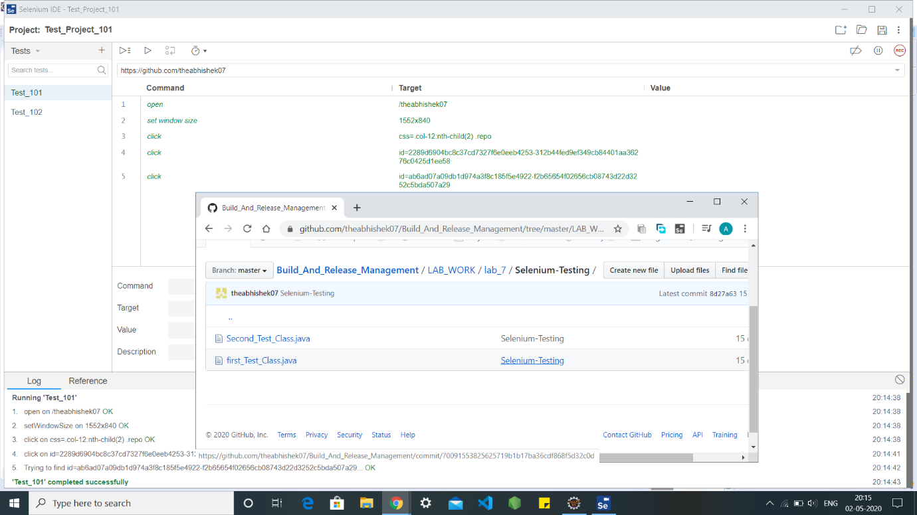

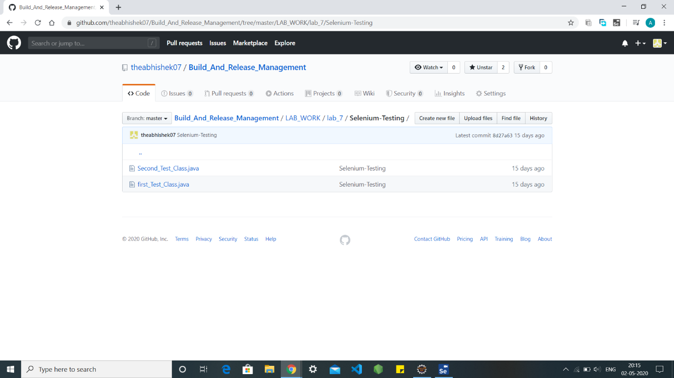

By typing the commands in another test i.e. Test102 : -

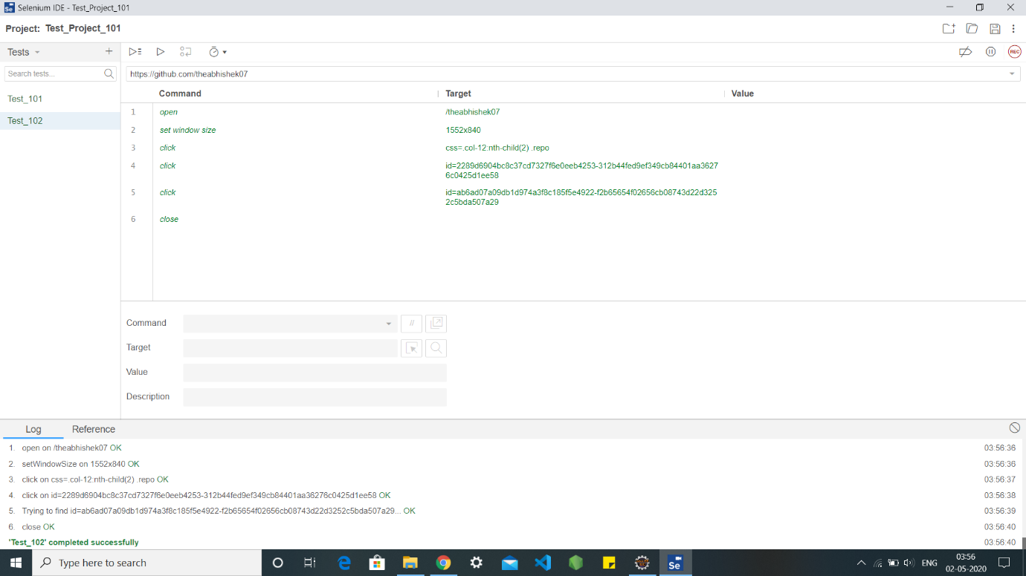

**EXPERIMENT-8**

**Aim: -Selenium WebDriver Perform Automation testing using Selenium Web Driver for testing a web page**

**Project name: - Demo_Class**

**Class name: - First.java**

**Input Code: -**

**package** selenium_test;

**import** org.openqa.selenium.By;

**import** org.openqa.selenium.Keys;

**import** org.openqa.selenium.WebDriver;

**import** org.openqa.selenium.chrome.ChromeDriver;

**public** **class** First {

**public** **static** **void** main(String[] args) {

// declaration and instantiation of objects/variables

System.*setProperty*("webdriver.chrome.driver", "D:\\chromedriver_win32\\chromedriver.exe");

WebDriver driver=**new** ChromeDriver();

// Launch website

driver.navigate().to("http://www.google.com/");

// Click on the search text box and send value

driver.findElement(By.*name*("q")).sendKeys("DEVOPS ABHISHEK SHARMA");

// Click on the search button

//driver.findElement(By.name("btnK")).click();

driver.findElement(By.*name*("q")).sendKeys(Keys.***ENTER***);

}

}

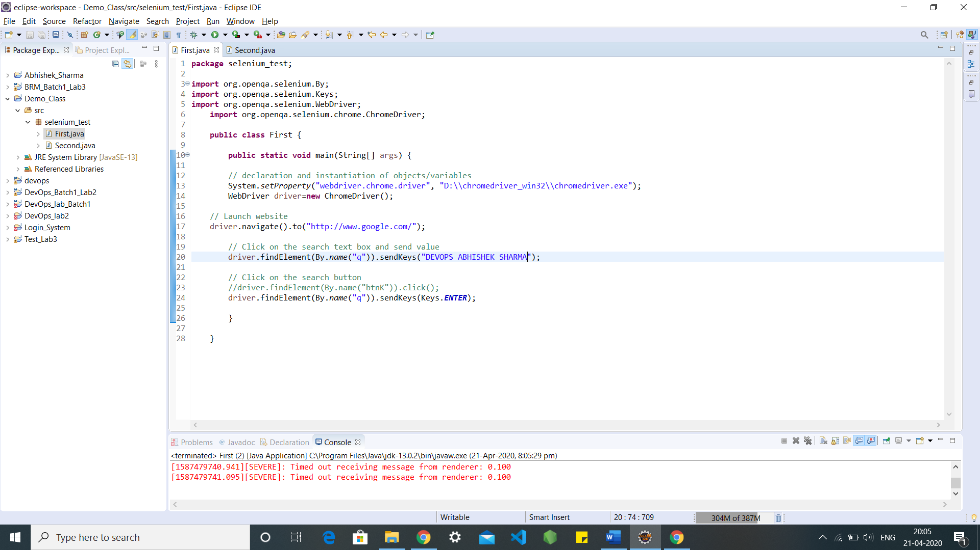

**Output Screen: -**

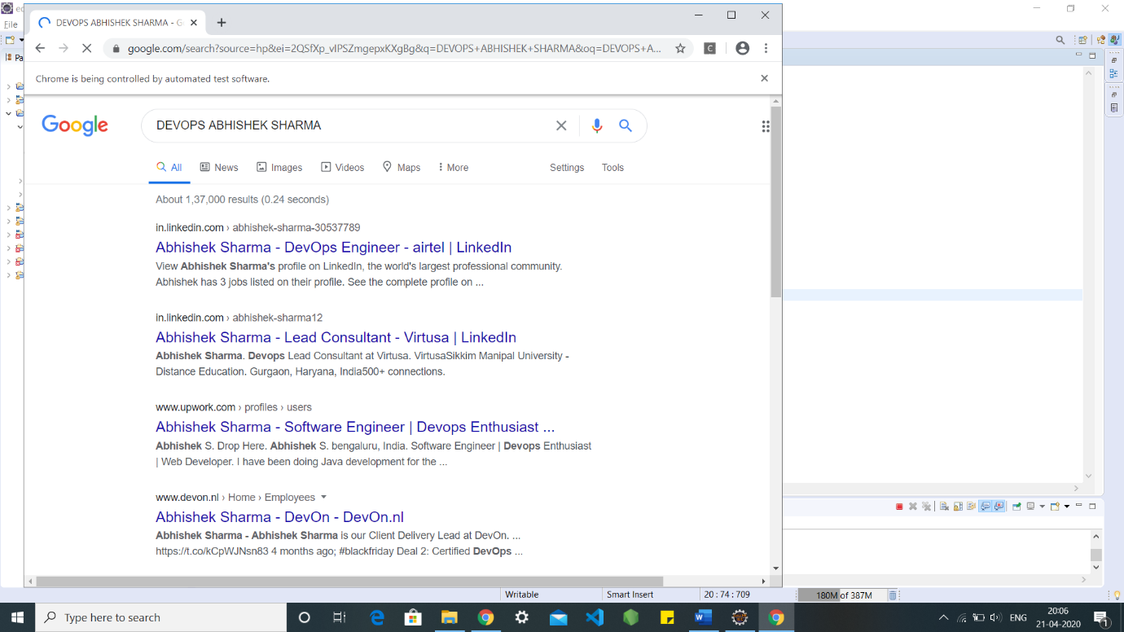

**Class name: - Second.java**

**Input Code: -**

**package** selenium_test;

**import** org.openqa.selenium.WebDriver;

**import** org.openqa.selenium.chrome.ChromeDriver;

**public** **class** Second{

**public** **static** **void** main(String[] args) {

// System Property for Chrome Driver

System.*setProperty*("webdriver.chrome.driver","D:\\chromedriver_win32\\chromedriver.exe");

// Instantiate a ChromeDriver class.

WebDriver driver=**new** ChromeDriver();

// Storing the Application Url in the String variable

String url = ("https://www.google.co.in/");

//Launch the ToolsQA WebSite

driver.get(url);

// Storing Title name in the String variable

String title = driver.getTitle();

// Storing Title length in the Int variable

**int** titleLength = driver.getTitle().length();

// Printing Title & Title length in the Console window

System.***out***.println("Title of the page is : " + title);

System.***out***.println("Length of the title is : "+ titleLength);

// Storing URL in String variable

String actualUrl = driver.getCurrentUrl();

**if** (actualUrl.equals("https://www.google.co.in/"))

{

System.***out***.println("Verification Successful - The correct Url is opened.");

}

**else**{

System.***out***.println("Verification Failed - An incorrect Url is opened.");

}

// Storing Page Source in String variable

String pageSource = driver.getPageSource();

// Storing Page Source length in Int variable

**int** pageSourceLength = pageSource.length();

// Printing length of the Page Source on console

System.***out***.println("Total length of the Pgae Source is : " + pageSourceLength);

//Closing browser

driver.close();

}

}

**Output Screen: -**

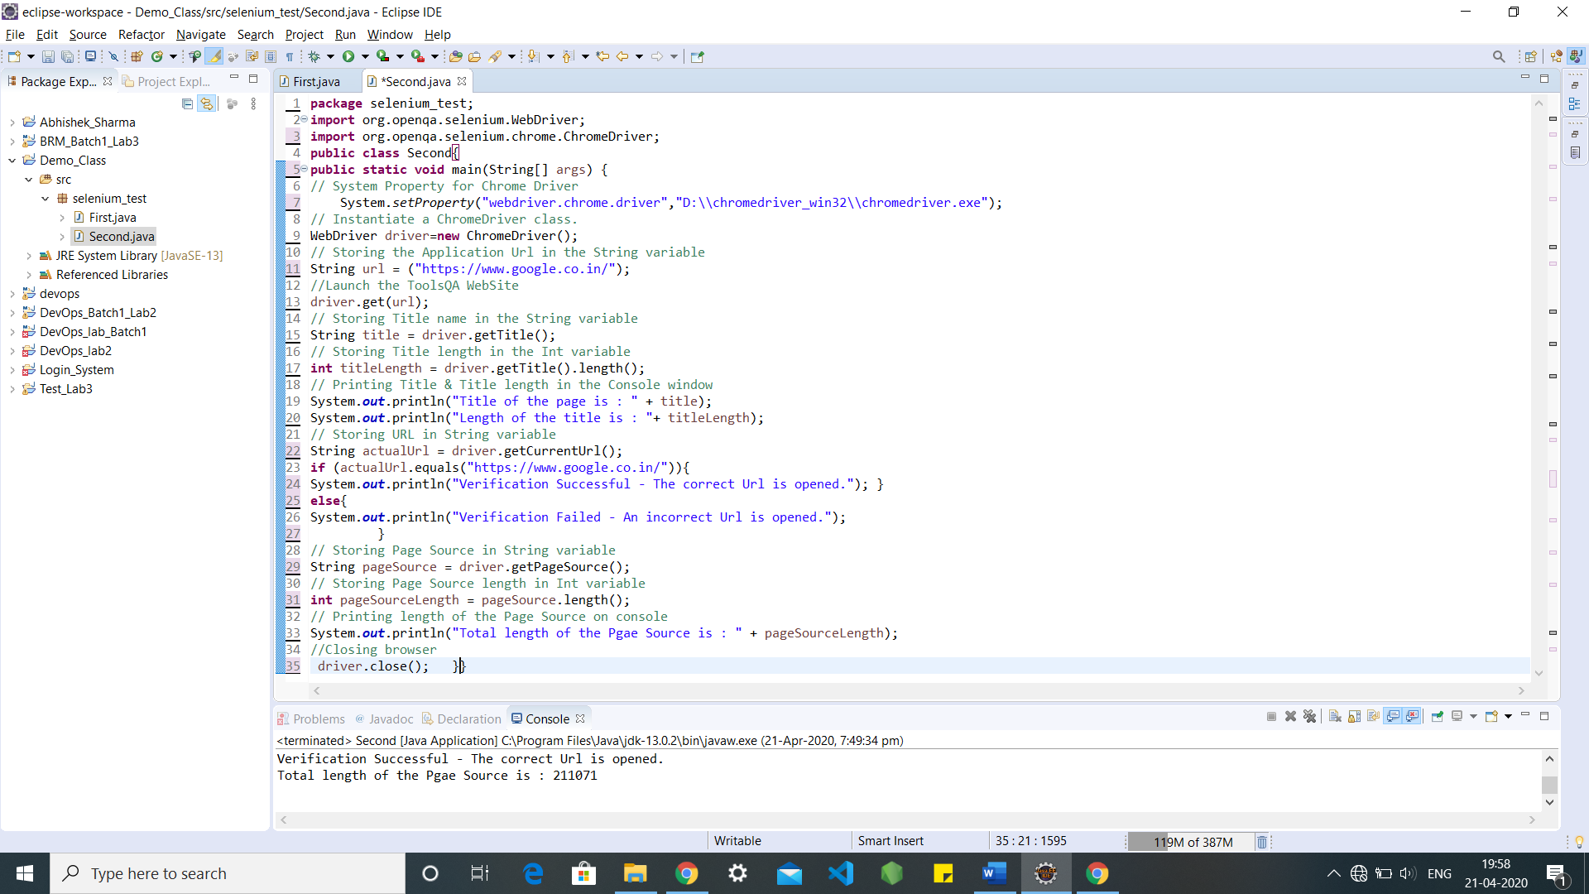

**EXPERIMENT-9**

# Aim: Build Profile using Maven

**Start: -**

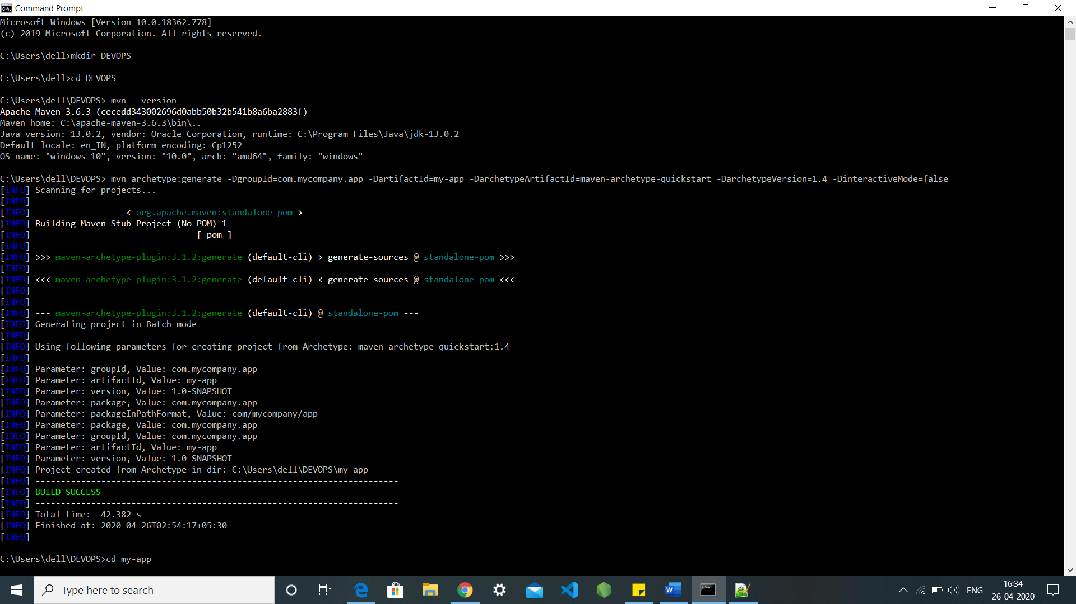

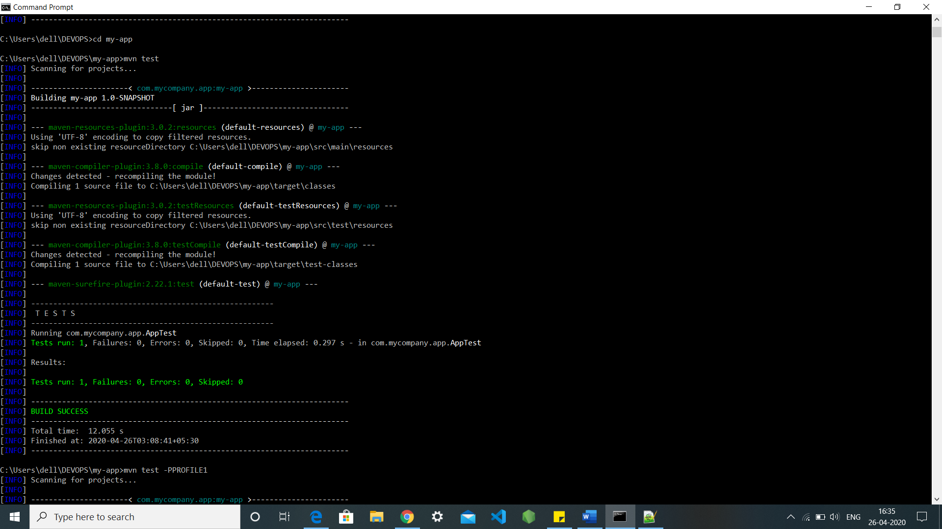

There are several methods to implement the Build profile run, they are as follows: -

**Method 1: -**

Add profile stack into the pom.xml file and run through cmd using -P(profilename)

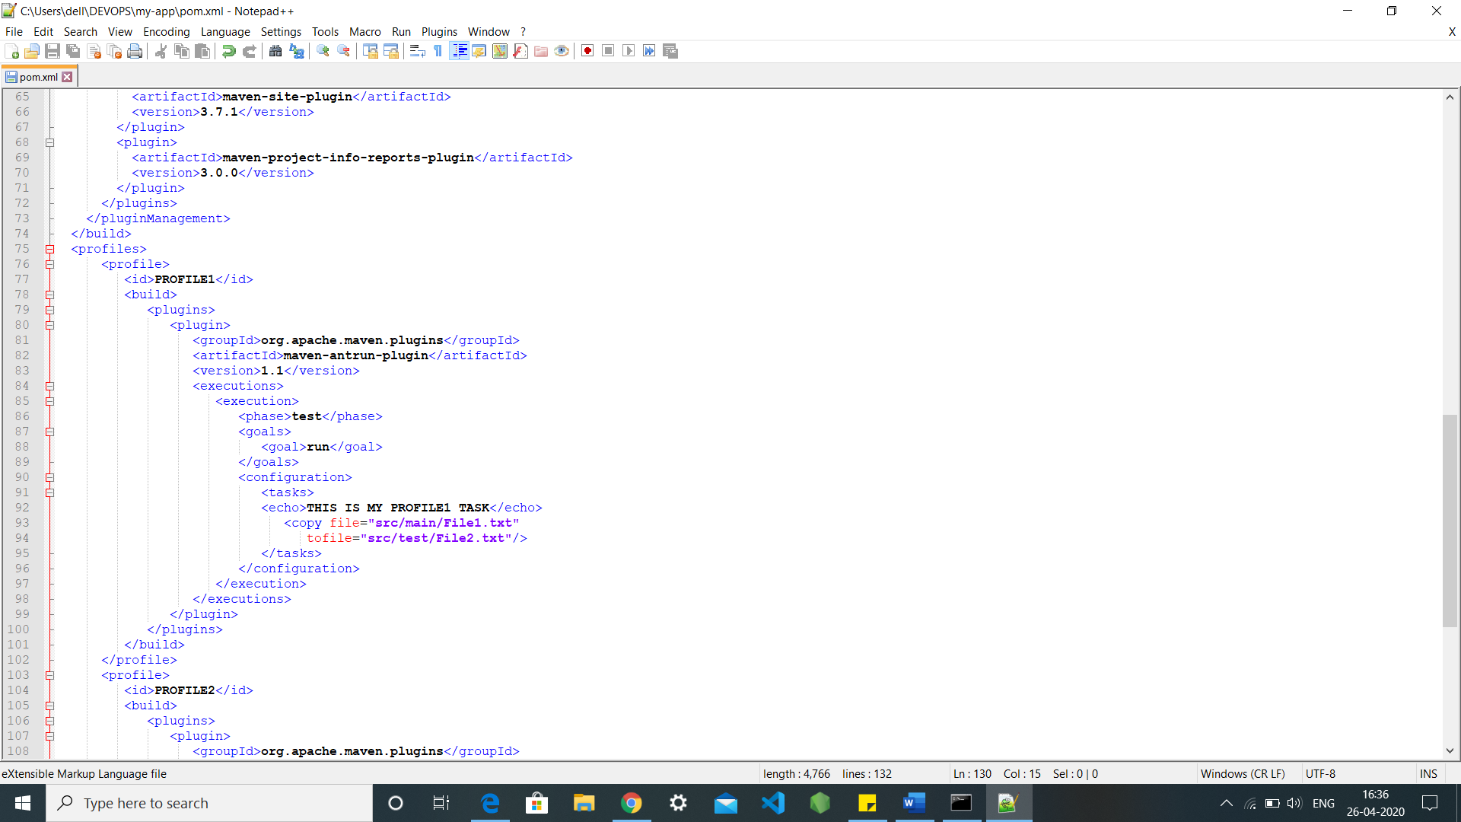

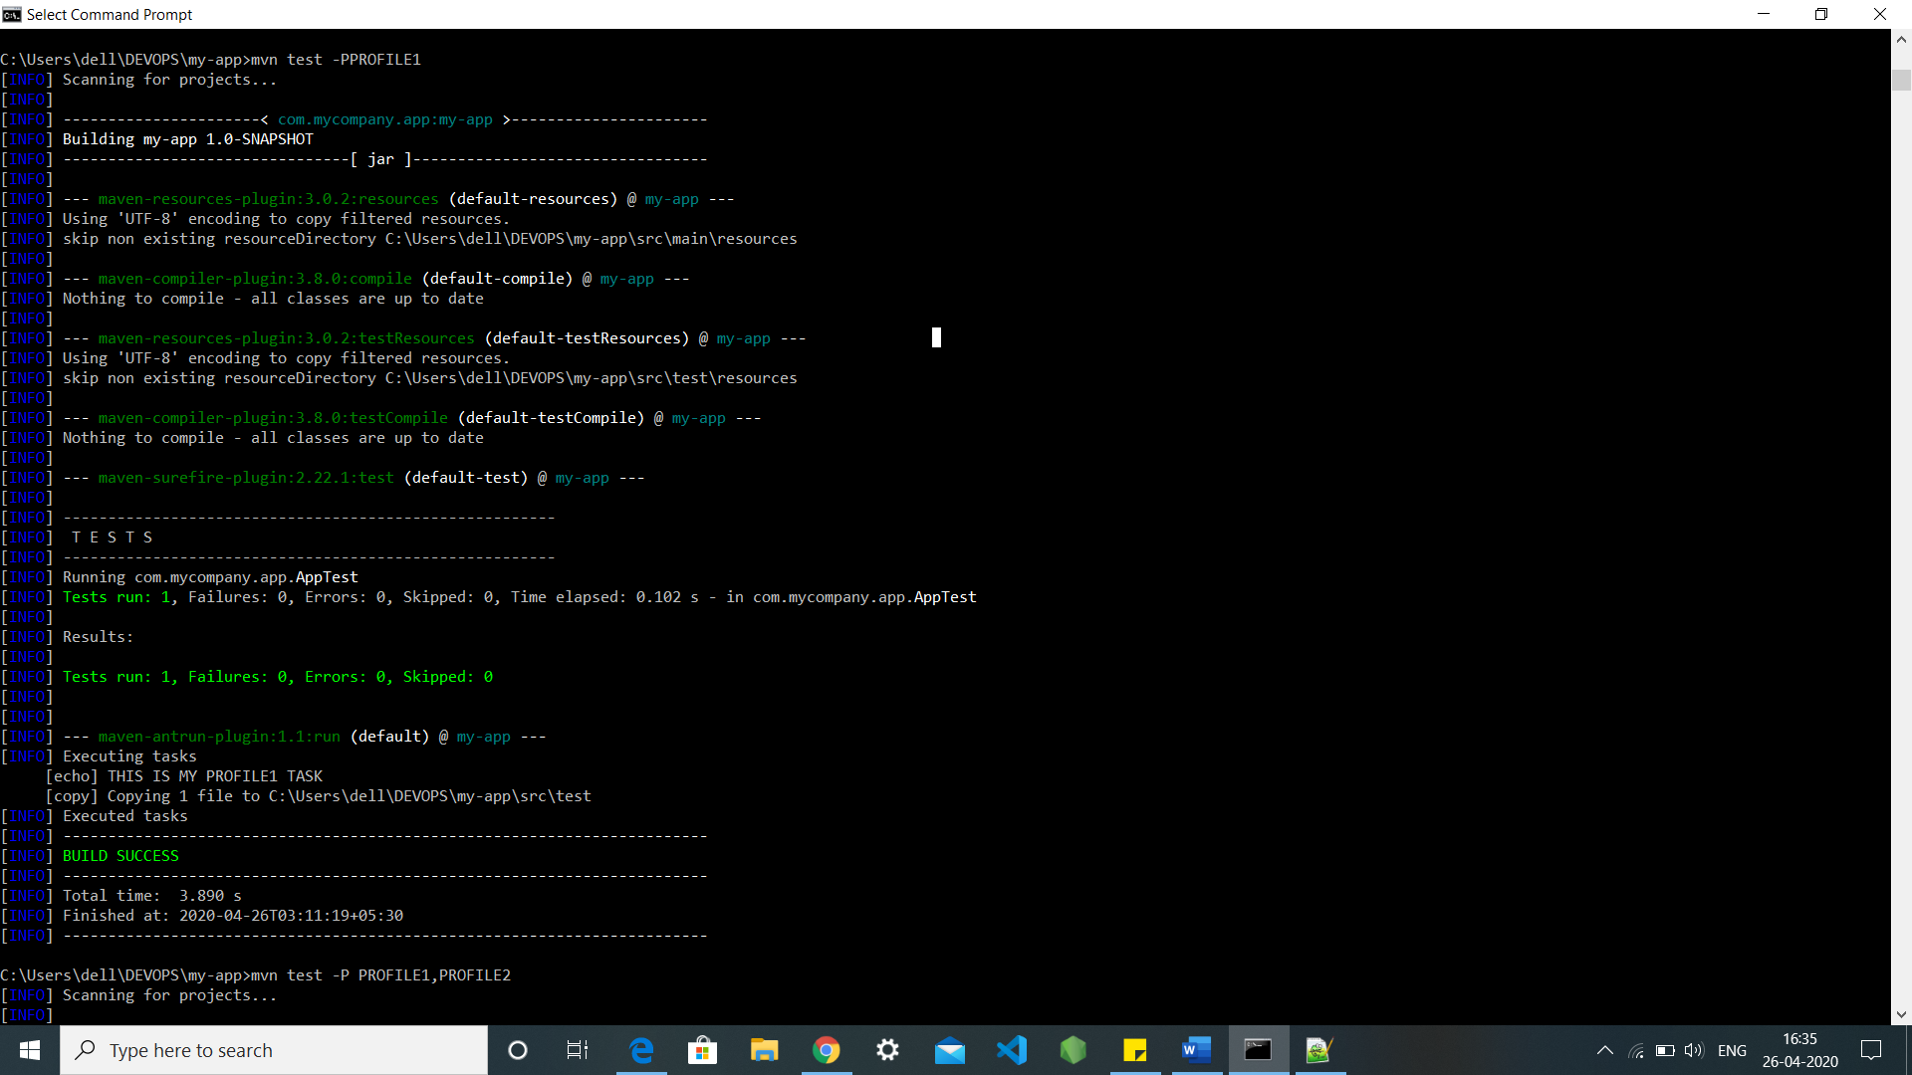

**Method 2: -**

We can execute multifile profiles though cmd with the command -P(profilename1,profilename2)

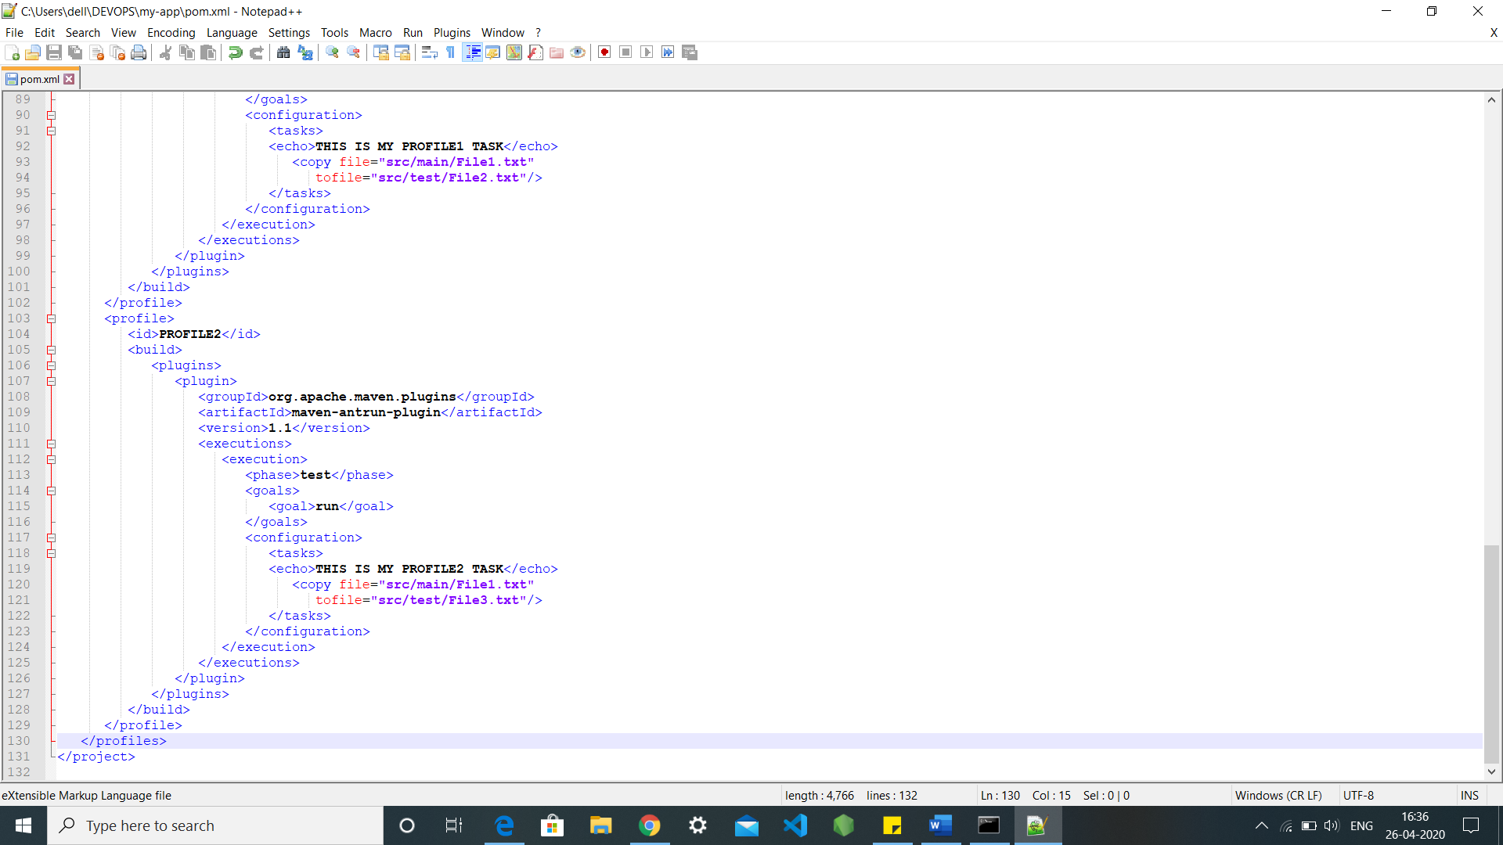

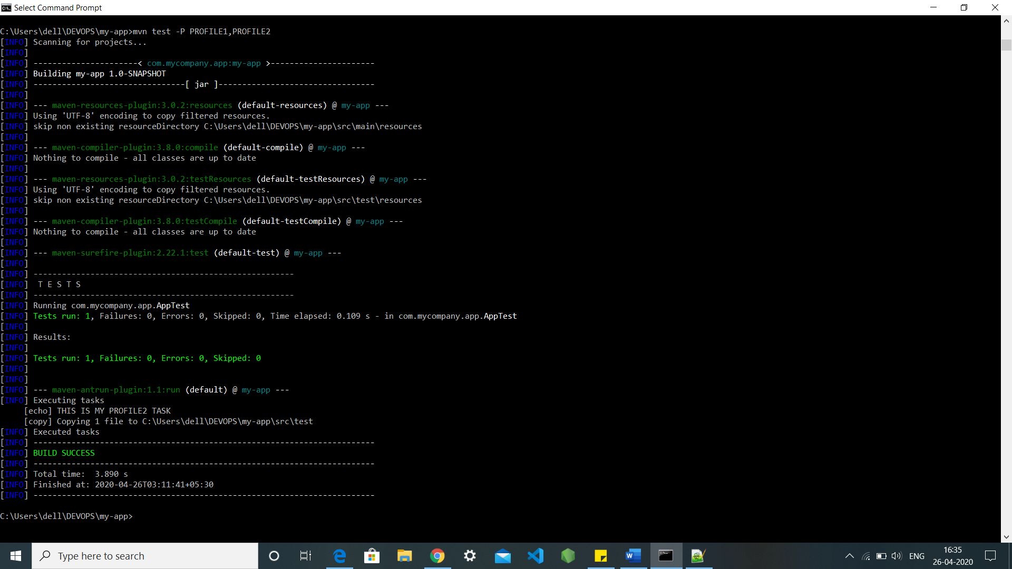

**Method 3: -**

If we ant to run the all the profiles available in the project for this we need to edit into user home Settings.xml file and add all the profile id’s into it and hence we can execute all the profiles in one go though cmd by using the command mvn test

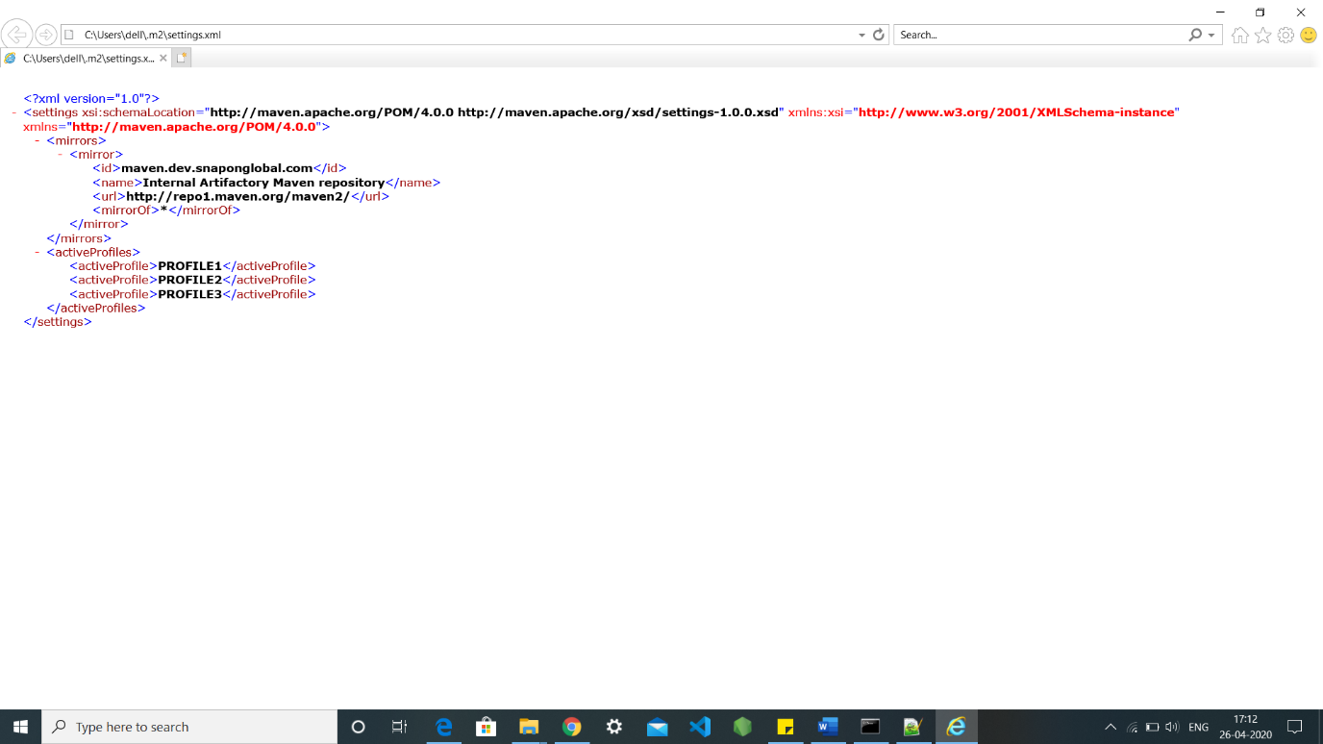

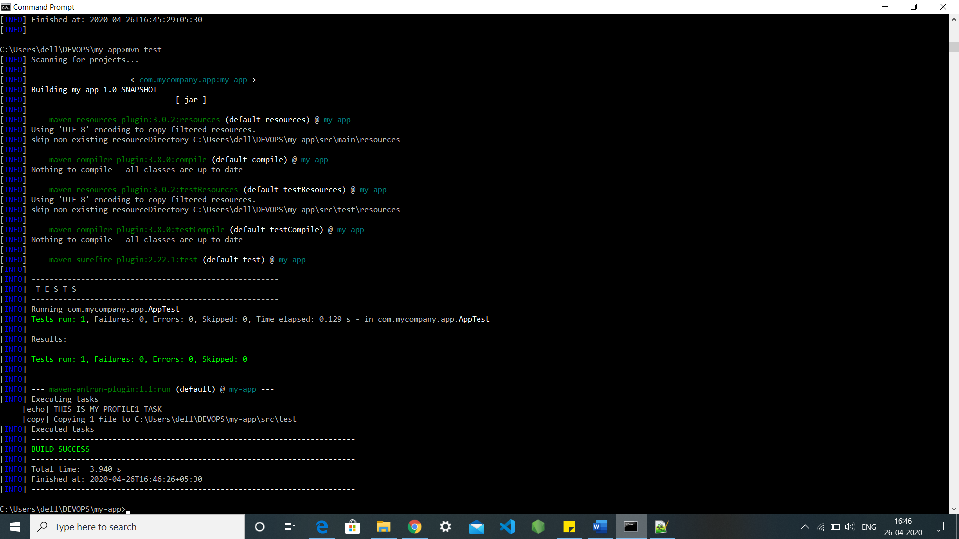

**Method 4: -**

We can also execute the profile but adding some limitations into the pom.xml file like it could only be executed when your system consists of windows XP with some specified version of it.

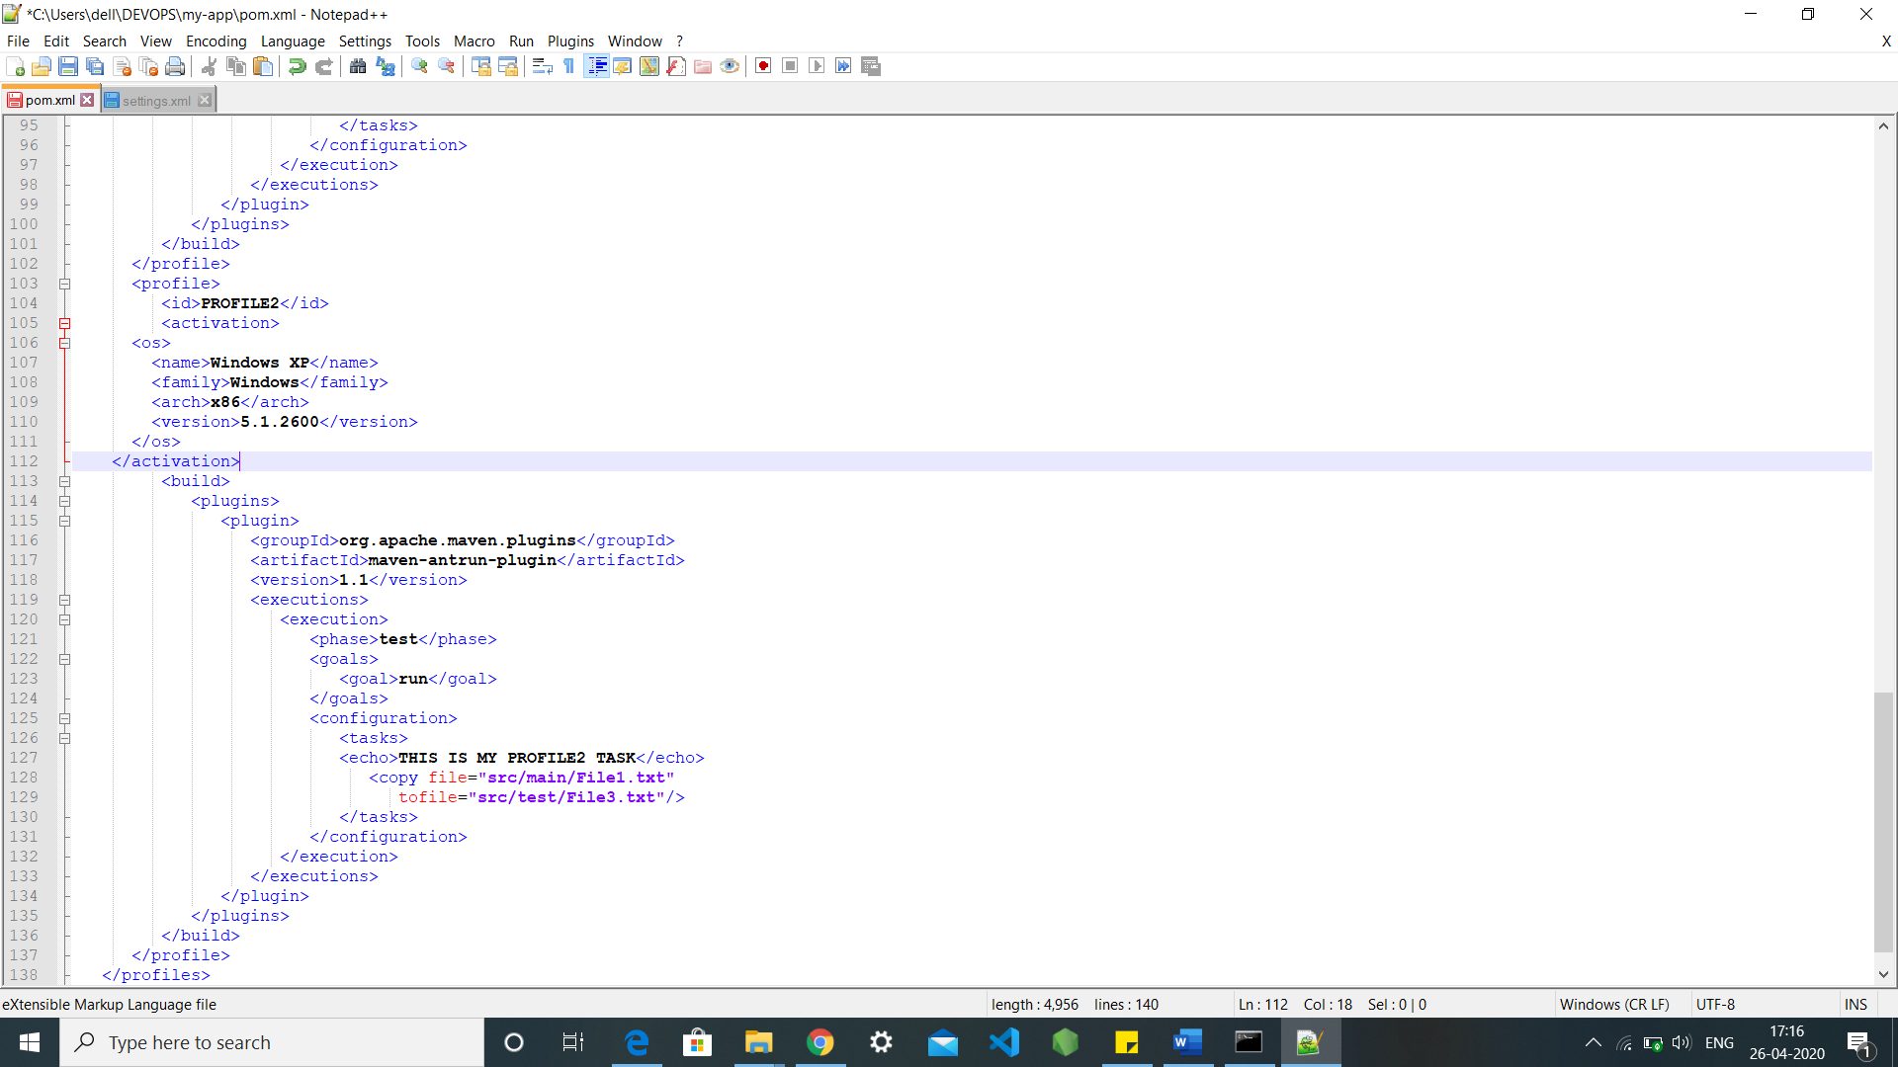

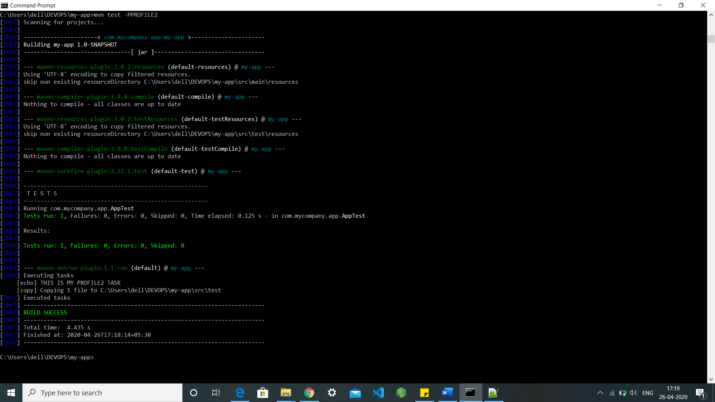

**Method 5: -**

To execute the profile we can also write the activation stack into the profile stack that will always be true to run the profile through the cmd using the command mvn test.

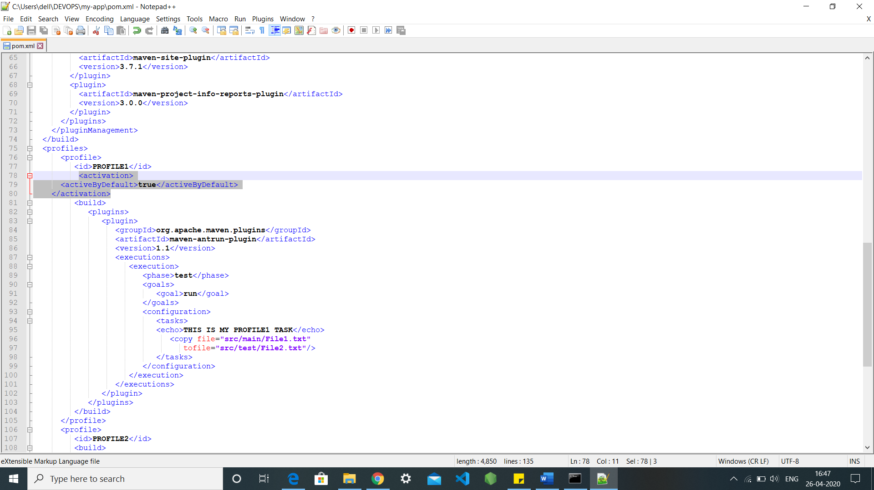



**Method 6: -**

By using Debug we can execute our profile though the command mvn test -Ddebug=true

.

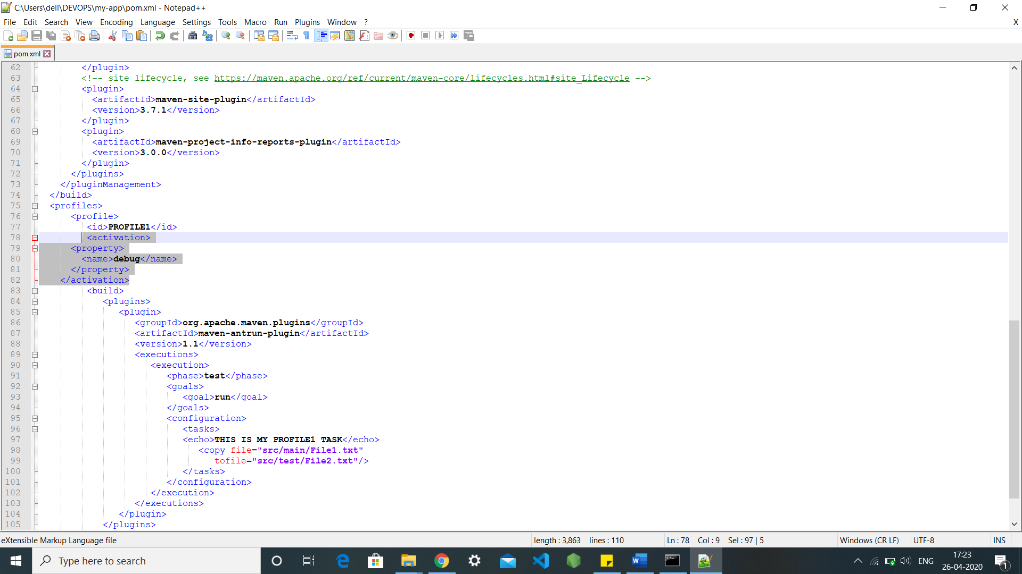

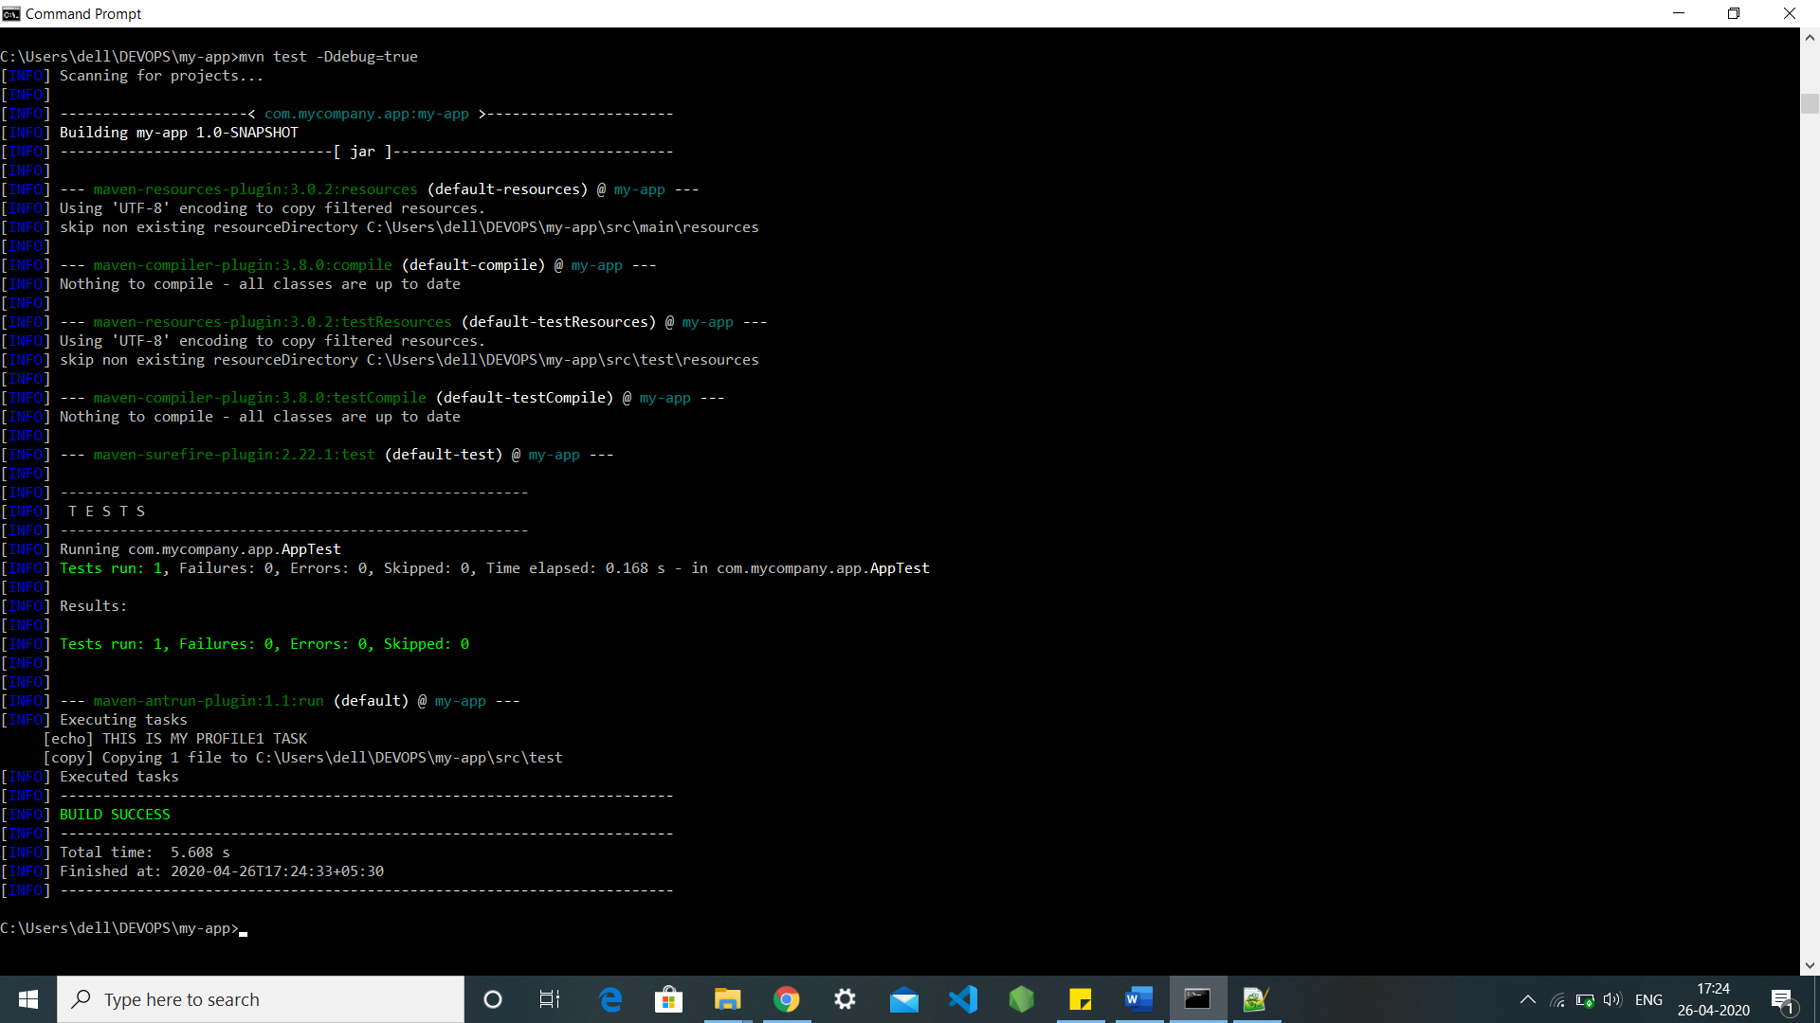

**Method 7: -**

We can also do this by setting up some set specified environments into out profile to execute them so the no one except us can run our secret profile using cmd through the command mvn test -Denv=test

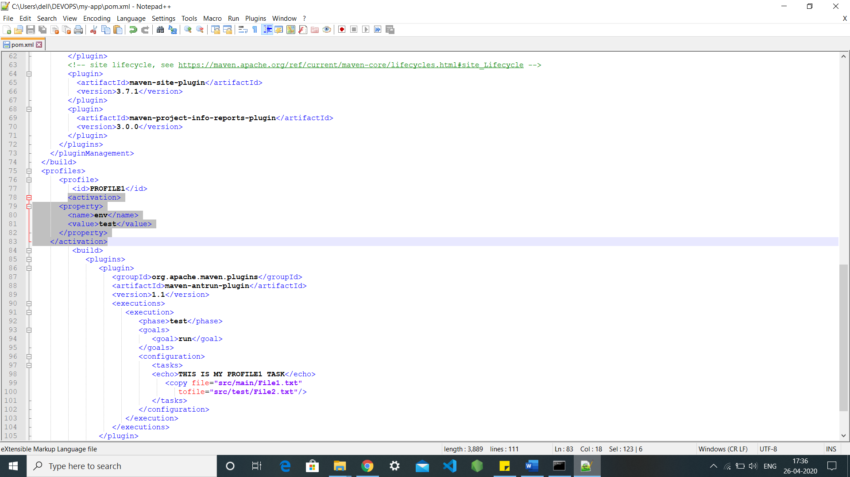

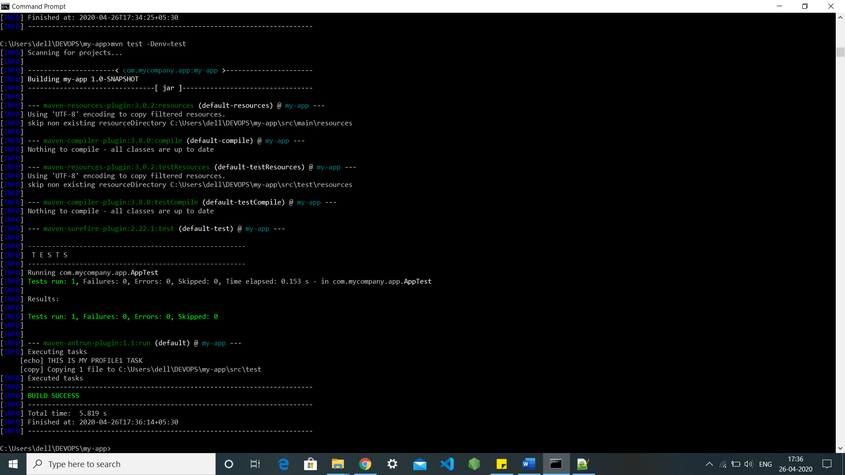

**Method 8: -**

We can also make it run through the unknown file present in our systems using the command mvn test.

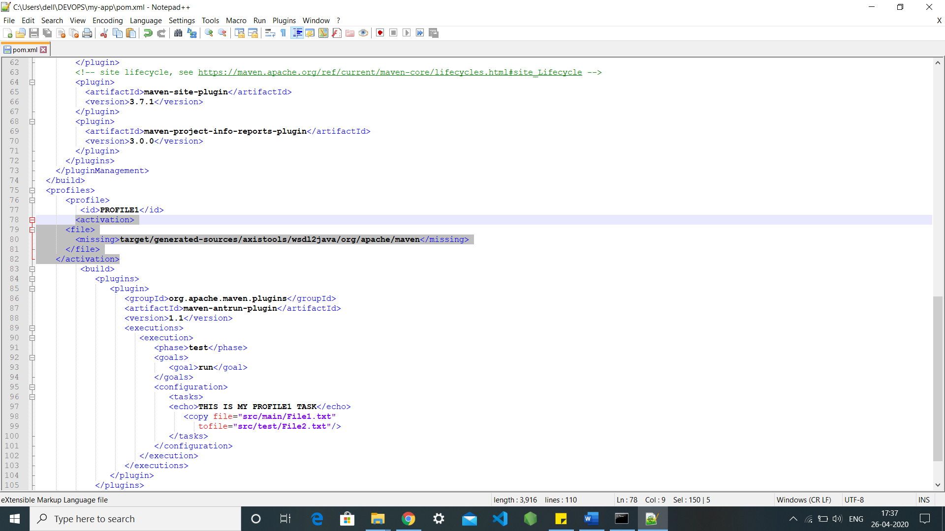

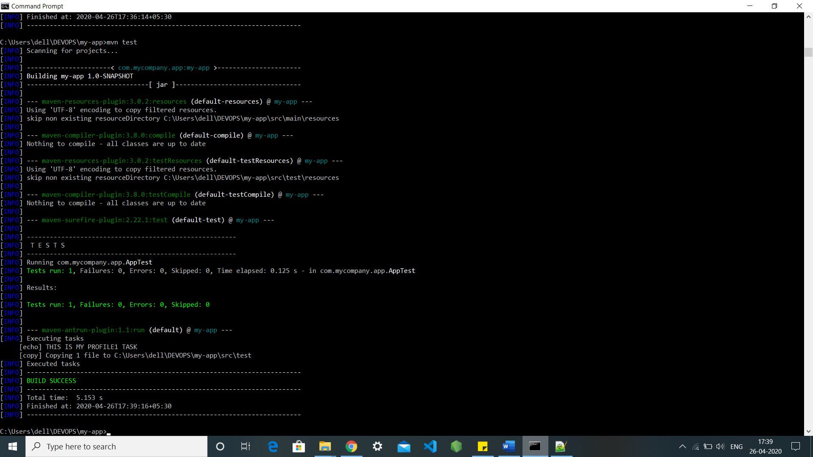

**EXPERIMENT-10**

**Aim: Integration using GitHub Create a complete Maven project and push in GitHub repository for Continuous Integration.**

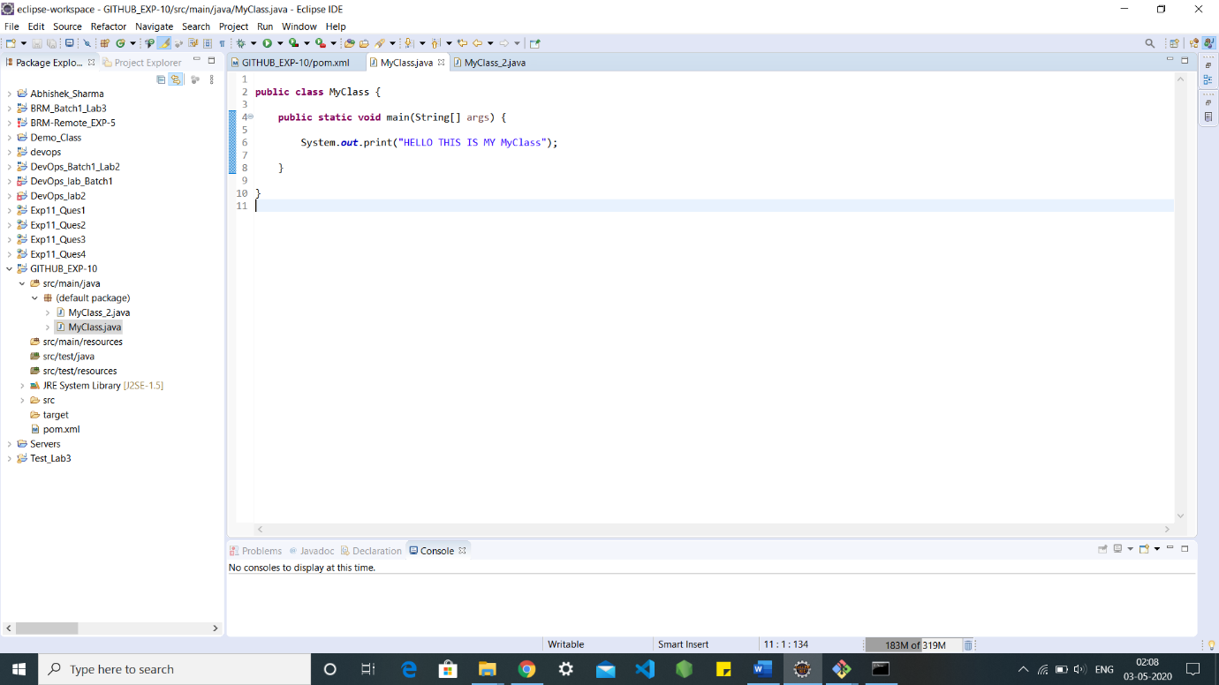

Created a repository with name BRM_PROJECT: -

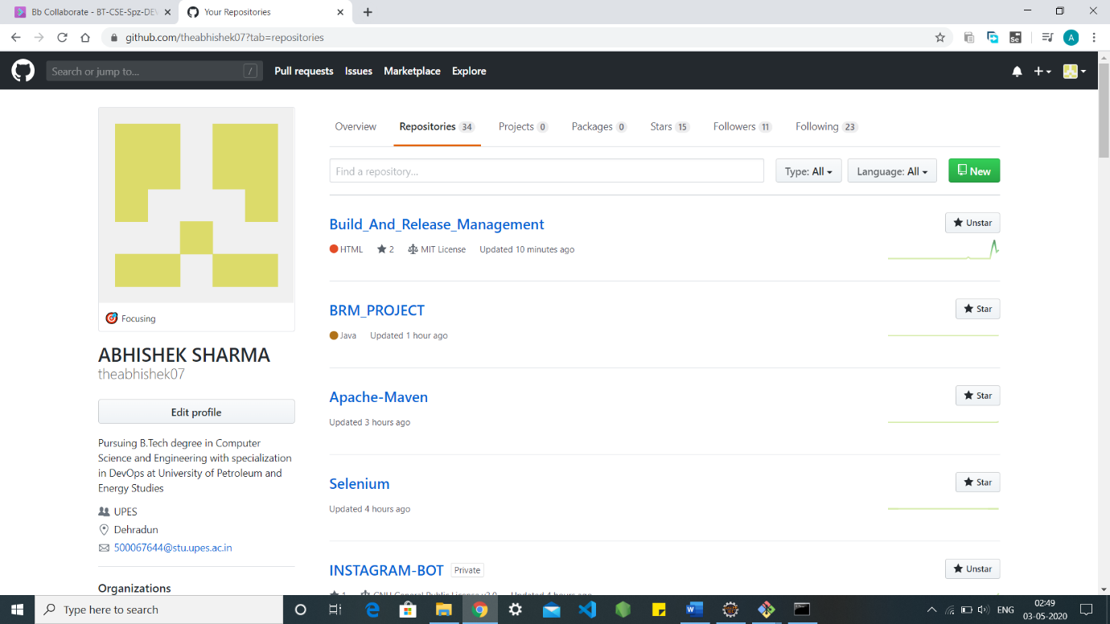

Adding and pushing files through bash: -

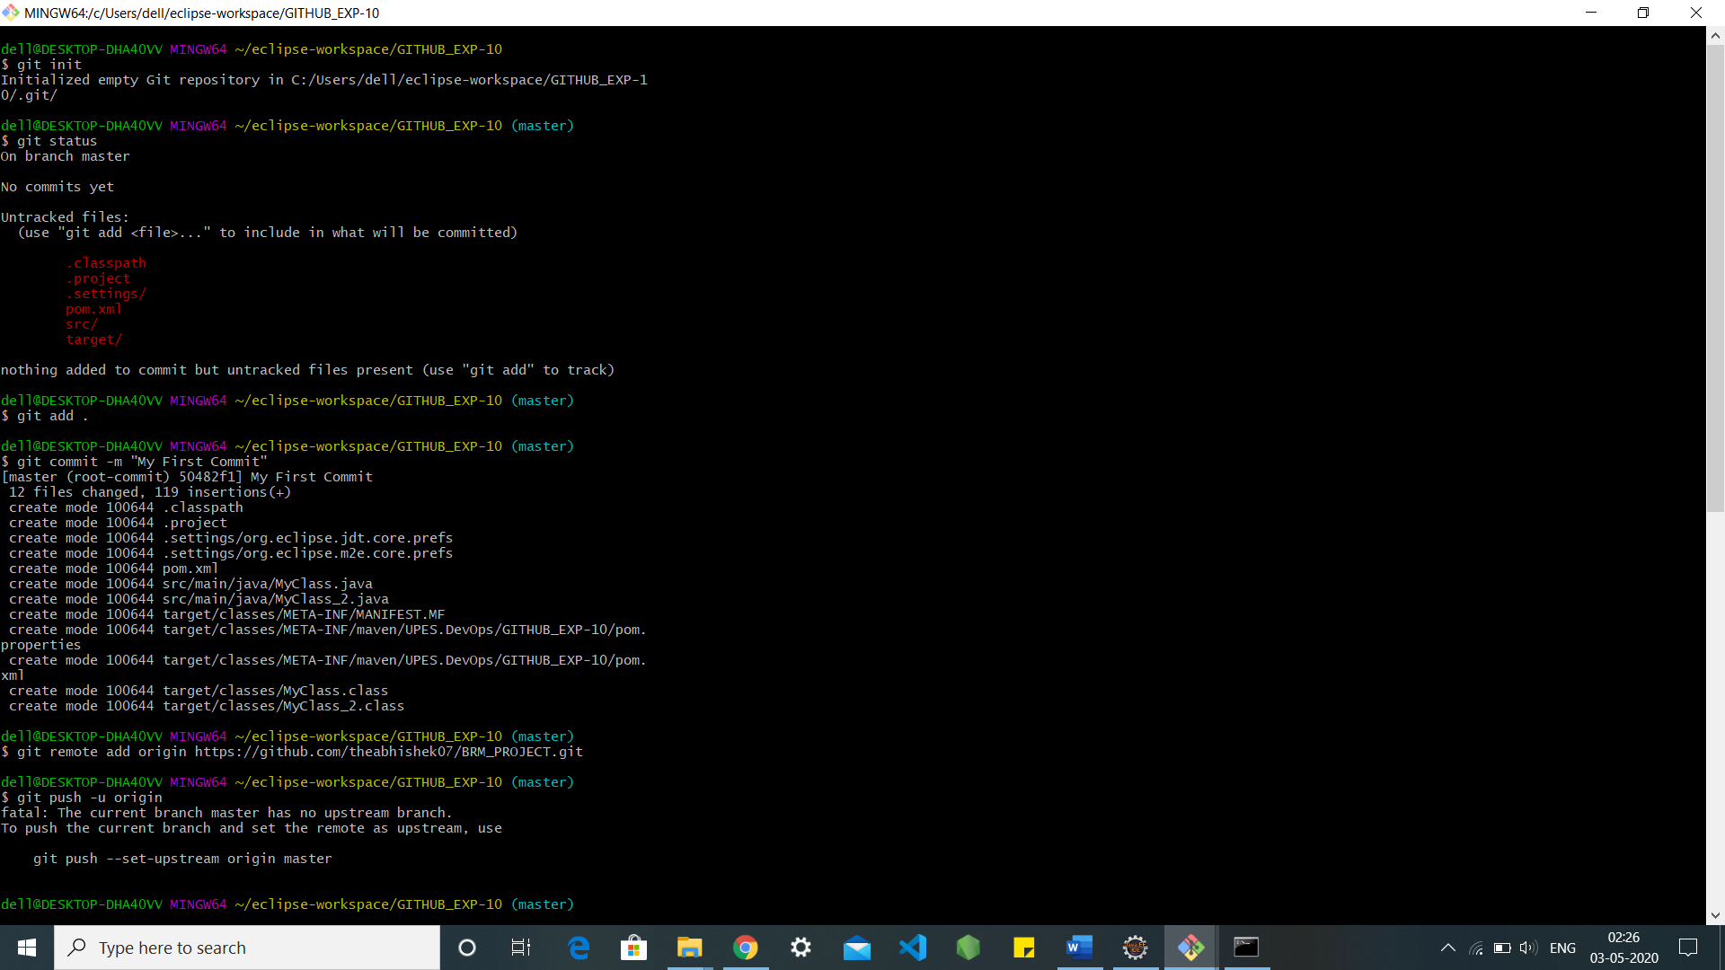

After pushing into the GitHub: -

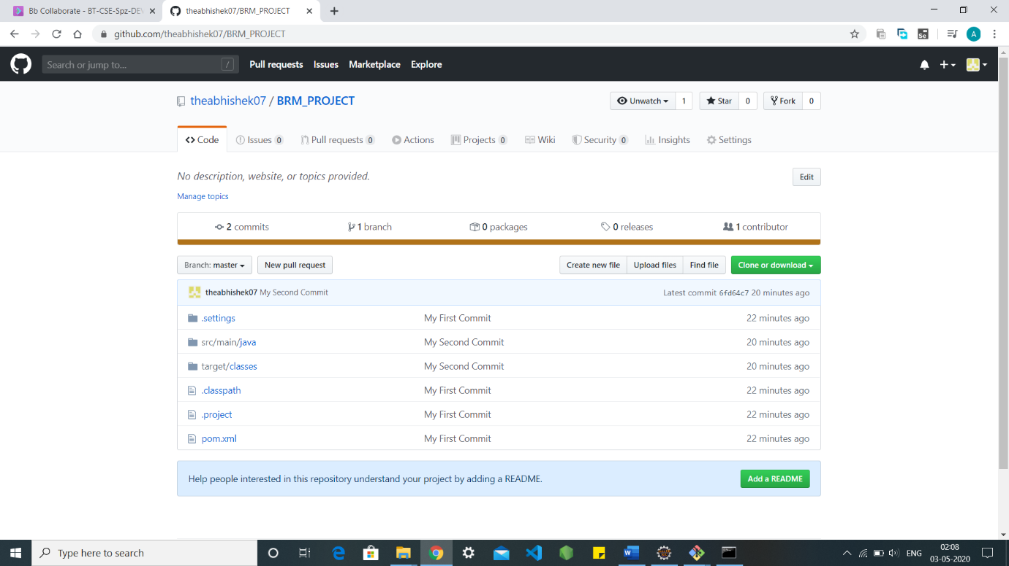

Adding class2 in the local machine: -

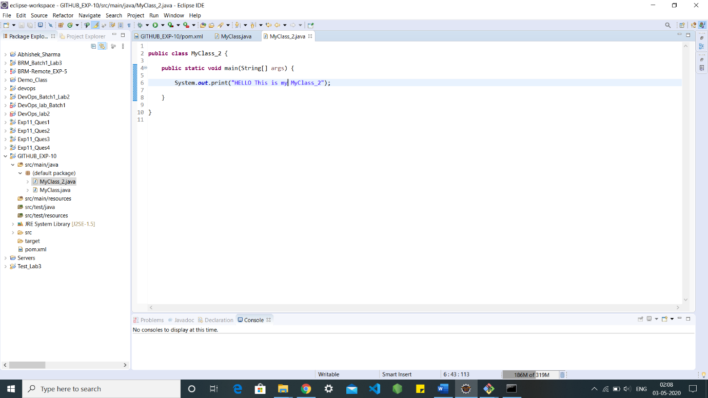

Adding and pushing MyClass_2 through bash: -

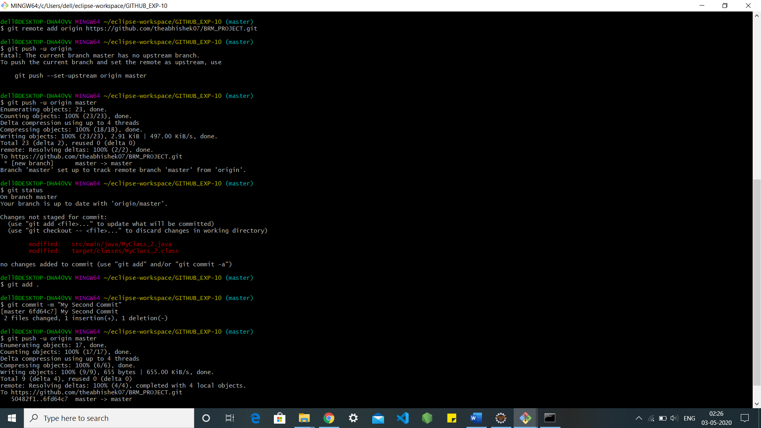

After pushing that MyClass_2 from the local into GitHub BRM_PROJECT: -



COMMITS: -

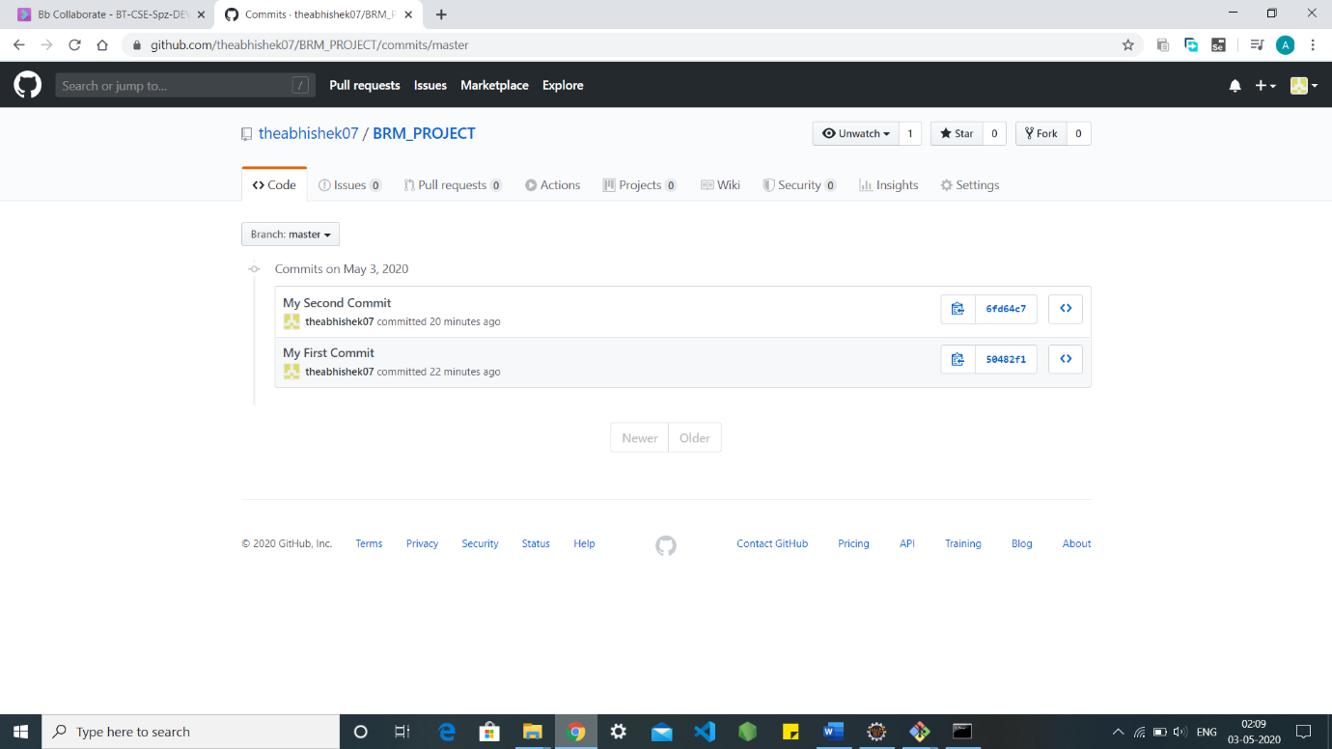

TO CHECK MY GITHUB [CLICK](https://github.com/theabhishek07?tab=repositories).